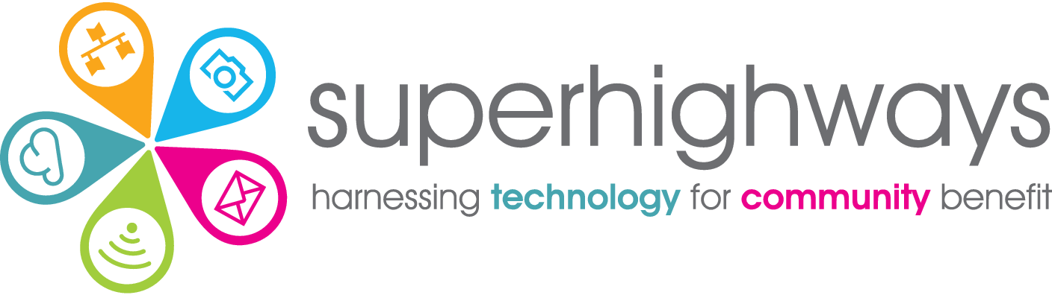

# Recruitment Pack

Data Support Adviser

## About us

Superhighways, a project of Kingston Voluntary Action, believes in strong, adaptable communities confidently using data and digital to meet their needs and aspirations. We're on a mission to help small charities and community groups in London gain essential digital and data skills, backed by the right tech, to achieve their goals.

Our values are lived in the way we deliver our services and activities.

We are:

* **Relationship centred:** we build meaningful relationships based on respect, honesty and care
* **Capability-minded:** we are approachable and patient, encouraging learning by doing, where no question is a silly question
* **Committed to value:** we meet people and teams where they are, finding the most appropriate and forward-thinking solutions
* **Enthusiastically curious**: we are always discovering new techniques and tools, offering engaging ways of learning and bringing fun and playfulness to all we do
* **Community spirited:** we foster collaboration and togetherness, connecting people with shared experiences for the good of the whole community, leading when appropriate

Our small but mighty team run a range of projects and services, alone and working collaboratively in partnership with others. See [www.superhighways.org.uk](http://www.superhighways.org.uk/) for further information.

Our data support programme

We are funded by Trust for London to deliver a data capacity building programme for London’s grassroots organisations working for a fairer and more equal London, so that they can better use data to shape services and raise the voice of their communities to influence change.

These organisations are often at the very beginning of their data journeys and so our interventions focus on the small steps they can take to progress with their data use and realise tangible outcomes as a result.

About you

We are looking for an exceptional individual to join our small friendly team to develop and deliver our data support offer under the Trust for London funded programme and beyond. You’ll be working alongside Superhighways colleagues to run a comprehensive data training programme, including regular Excel sessions, and provide one to one advice and hands-on support to small charities and community groups in London.

You'll be as comfortable crunching numbers, analysing datasets and acting on insights as you are running small group training and facilitating workshops. Your excellent communication skills will help non-technical learners develop the confidence and critical thinking skills they need to get started with analysing data and developing their organisation's data maturity. A passion for Excel is a must!

You will be enthusiastic, enjoy working on a variety of tasks, and motivated to further your interest in data use. Most importantly, you’ll have a passion to make a real difference within the community, and empower small charities and community groups to robustly use data to influence change.

Recruitment timetable

To apply for the post – please download and complete this application form [from our website](https://superhighways.org.uk/we-are-hiring/) and return by mail to Superhighways, c/o Kingston Voluntary Action, Siddeley House, 50 Canbury Park Road, Kingston, KT2 6LX or email [jobs@superhighways.org.uk](mailto:jobs@superhighways.org.uk)

Closing date for applications Tuesday 13 September at 12 pm midday

Shortlisting decisions communicated Thursday 15 September

Interviews Tuesday 20 September

Data Support Adviser Job Description



Purpose: To enable small charities and community groups gain new data skills and approaches, to shape services, raise the voice of their communities and influence change.

Responsible to: Superhighways Manager

Salary & benefits: £34,340 per annum (FTE). Part time – 21 or 28 hours negotiable.

27 days annual leave + bank holidays. 3% pension.

Contract: Permanent contract (funded to December 2023, with the potential to extend subject to additional funding being secured).

Location: Flexible hybrid working, remotely from home and in our current central Kingston office, with monthly in person team meetings. Please note we are likely to be phasing in increased face to face advice, training and onsite visits where most appropriate, from 2023, which will require travel across London.

Summary

To provide data training, advice and support for small charities and community groups in London, covering collecting, storing, analysing and presenting data for shaping services and influencing change.

Key tasks

1. Delivering online and in person group training including regular beginners and intermediate Excel sessions.
2. Providing one to one data support surgeries for small charities and community groups covering a wide range of data uses
3. Developing entry level support resources in a wide range of formats
4. Researching and testing digital tools to support data collection, storage, analysis and presentation e.g. online forms, databases and visualisation tools
5. Advising on data storytelling to raise the voice of communities and influence policy makers, funders and other stakeholders
6. Identifying and presenting case studies showcasing tangible outcomes from improved data practice
7. Sign posting to other relevant data support services, resources and external data sources
8. Supporting related work under our Datawise London programme and consultancy services as needed
9. Contributing content to the Superhighways eNews, social media posts and blogs
10. Monitoring and evaluating programme delivery to ensure high standards, inform future improvements, and meet targets set.

Other duties

1. Work as part of the Superhighways team and contribute to our overall aims and objectives
2. Attend team meetings and training as required
3. Operate in accordance with our values, policies and procedures
4. Work within agreed work plans, manage own work load and be self-servicing
5. Promote the work of the Superhighways and participate in any other activities as necessary

Key working relationships

1. Superhighways and Kingston Voluntary Action staff teams
2. London’s CVSs and other infrastructure agencies
3. London’s frontline civil society organisations

### Person specification



|  |  |  |
| --- | --- | --- |
| Requirements | Essential | Desirable |
| Educational attainment | * Degree level or equivalent | * Training or qualification in a data related subject * Teaching or related training / coaching qualification |
| Knowledge | * Demonstrable understanding of how to use qualitative and quantitative data for monitoring, evaluation and influencing change * Knowledge of data best practice including GDPR compliance | * Good understanding of the small charity and community group sector and challenges faced by frontline organisations |
| Experience | * Working on a range of data projects, analysing datasets and acting on insights * Using a range of data analysis and visualisation tools, techniques and systems * Supporting others in their use of data, including those with lower levels of data understanding and skills * Creating support resources in a range of formats to help others utilise data effectively beginners to more advanced levels * Sourcing and using data from a range of sources including open data | * Creating and delivering training courses online or in person * Implementing CRMs and database systems * Working within the small charity and community group sector |
| Skills | * Excellent analytical skills and critical thinking * Excellent organisational and workload management skills * Excellent digital skills including advanced Excel * Excellent oral and written communication skills, to a variety of audiences, adjusting to different levels of understanding and using plain English | * Training skills * Group facilitation skills * Microsoft 365 apps |
| Personal qualities | * A passion for using data to make a real difference for small charities and community groups * Friendly and approachable, patiently going the extra mile when needed * Enthusiasm to share knowledge and skills, and motivate others to learn * A committed team player with a collaborative, flexible and generous approach to working with colleagues and sector organisations * Commitment to working positively and valuing and celebrating diversity and inclusion * A proactive and self- motivated learner developing skills and testing new approaches & solutions |  |