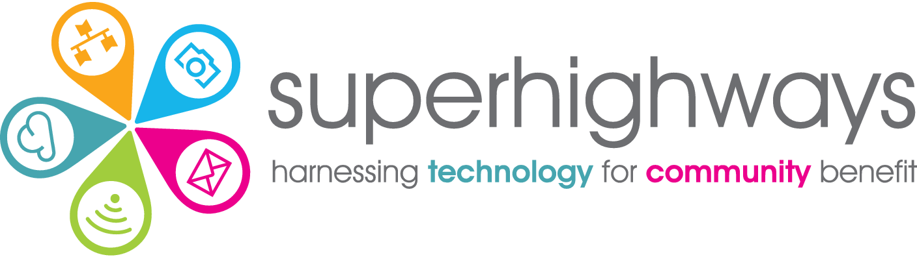

# Recruitment Pack

# Tech and Digital Support Adviser

## About us

Superhighways, a project of Kingston Voluntary Action, believes in strong, adaptable communities confidently using data and digital to meet their needs and aspirations. We're on a mission to help small charities and community groups in London gain essential digital and data skills, backed by the right tech, to achieve their goals.

Our values are lived in the way we deliver our services and activities.

We are:

* **Relationship centred:** we build meaningful relationships based on respect, honesty and care
* **Capability-minded:** we are approachable and patient, encouraging learning by doing, where no question is a silly question
* **Committed to value:** we meet people and teams where they are, finding the most appropriate and forward-thinking solutions
* **Enthusiastically curious**: we are always discovering new techniques and tools, offering engaging ways of learning and bringing fun and playfulness to all we do
* **Community spirited:** we foster collaboration and togetherness, connecting people with shared experiences for the good of the whole community, leading when appropriate

Our small but mighty team run a range of projects and services, both alone and working collaboratively in partnership with others. See [www.superhighways.org.uk](http://www.superhighways.org.uk/) for further information.

Digital Foundations programme

We have recently been awarded five-year funding from the National Lottery Community Fund to lead a partnership consisting of the HEAR Network, Refugee Council and VOICE Online Communities CIC, to support small charities and community groups gain the digital skills and tech infrastructure they need to run their organisation and amplify their impact.

Using a co-design approach, we are involving partners, infrastructure organisations and frontline organisations, to shape the programme of training, advice and support, and to maximise our reach and outcomes.

Small charities and community groups in the capital have extraordinary passion and commitment, running invaluable services and activities for local people in London, and using technology and the online world every day.

Following the transition to online working and delivery during the pandemic, organisations are now taking stock and are keen to progress their digital use, skills and infrastructure, yet they are overwhelmed with choices and concerned about security. At this time when demand for their services is ever increasing, they are looking for some support. That’s where the Digital Foundations programme and the new Tech & Digital Support Adviser role comes in….

About you

We are looking for an exceptional individual to join our small friendly team to develop our tech and digital support offer in collaboration with our partners. You’ll be working alongside Superhighways colleagues, including the Digital and comms lead, to co-design and deliver this new programme of training, advice and support, responding to the needs of smaller charities and community groups, including the HEAR Network’s members and London’s Refugee Community Organisations.

You’ll be enthusiastic, enjoy working on a variety of tasks, and motivated to further your interest in digital technologies. You’ll know that small community organisations are crucial to civic life in London, often at the forefront of helping people overcome the toughest challenges. You’ll be determined to ensure that they can continue to do what they do best, backed by the right technology that works for them.

You’ll be a patient, clear communicator, able to explain complex processes and technology in ways that people with different backgrounds, knowledge and expertise can understand and action. You will want to empower and inspire both small charities and community groups and the people they support to be the change they want to see in the capital and beyond.

Recruitment timetable

To apply for the post – please download and complete the Application form and Equal opportunities monitoring form [from our website](https://superhighways.org.uk/we-are-hiring/) and return by mail to Superhighways, c/o Kingston Voluntary Action, Siddeley House, 50 Canbury Park Road, Kingston, KT2 6LX or email [jobs@superhighways.org.uk](mailto:jobs@superhighways.org.uk)

Closing date for applications: Tuesday 13 September at 12 pm midday

Shortlisting decisions communicated: Thursday 15 September

Interviews: Monday 19 September

Tech and Digital Support Adviser Job Description



Purpose: To enable small charities and community groups gain the digital skills and tech infrastructure they need to run their organisation and amplify impact.

Responsible to: Superhighways Manager

Salary & benefits: £35,855 per annum (FTE). Part time or full time – 28 or 35 hours negotiable.

27 days annual leave + bank holidays. 3% pension.

Contract: Permanent contract (funded at current levels to September 2025, with the potential to extend subject to additional funding being secured).

Location: Flexible hybrid working, remotely from home and in our current central Kingston office, with monthly in person team meetings and occasional in person partnership meetings. Please note we are likely to be phasing in increased face to face advice, training and onsite visits, where more appropriate, from 2023, which will require travel across London.

Summary

To work with the Superhighways team and partners to deliver the new Digital Foundations programme, providing tech and digital advice and support to small charities and community groups in London, including delivering training and creating resources, with a focus on tech and digital basics and best practice.

Key tasks

1. Provide tech support and advice covering a wide range of strategic and operational issues relating to the use of tech and digital by small charities and community groups e.g. registering a domain, advising on file storage and collaboration tools, Office 365 set up and device troubleshooting
2. Provide remote support via phone, email and video call as well as an outreach service, travelling to visit organisations or running 1:1 digital surgeries from community venues
3. Identify (or develop) and use relevant diagnostic tools, frameworks and templates for benchmarking digital maturity and planning and capturing progression
4. Identify training needs and input into the development of the Superhighways training offer – creating and delivering accessible courses, online and in person, in response to needs e.g. bite size cyber security sessions
5. Create support resources including step by step guides and how to videos to enable small groups to implement new digital tools and improve their tech infrastructure
6. Research and test new apps and digital tools appropriate for use by small local groups e.g. appointment booking systems
7. Signpost organisations to other support services and sources of information, building relationships with relevant suppliers & stakeholders as appropriate
8. Contribute to ongoing co-design of the Digital Foundations programmes alongside our partners, including co-facilitating co-design and peer learning sessions with frontline & infrastructure organisations
9. Contribute to Superhighways communications including developing relevant content for our website, eNews and social media and any other activities to extend our service
10. Contribute to monitoring and evaluating the Digital Foundations programme delivery to ensure high standards, inform future improvements and meet targets set

Other duties

1. Update our CRM (AIDE), logging all support given and training attended, so that we can provide accurate data detailing the uptake and usage of services for our funder and other stakeholders
2. Work as part of the Superhighways team and contribute to our overall vision and mission, promoting our work and participating in any other related activities
3. Provide support as part of our Tech support service as necessary
4. Attend team meetings and training as required
5. Work within agreed work plans, manage own workload and be self-servicing, including related admin as necessary
6. Operate in accordance with the organisation’s values, policies and procedures

Key working relationships

* Superhighways and the wider Kingston Voluntary Action staff teams
* Digital Foundations programme partners
* London’s CVSs and other infrastructure agencies
* London’s frontline small charities and community organisations

### Person specification



|  |  |  |
| --- | --- | --- |
| Requirements | Essential | Desirable |
| Educational attainment | * Degree level or equivalent in a related subject | * Additional training or qualifications in technology, digital or a related subject * Teaching or related training or coaching qualification |
| Knowledge | * Wide ranging knowledge of digital technologies * Demonstrable understanding of how technology and digital can be utilised by small charities and community groups to run their organisation and amplify impact * IT security risks and mitigation practices | * Good understanding of the small charity and community group sector and challenges faced by frontline organisations * Knowledge of tech discounts available for the charity and social enterprise sector |
| Experience | * Setting up secure tech infrastructure for organisational use (hardware and systems) * Setting up and using a range of digital tools for organisational processes * Supporting others in their use of technology and digital, including those with lower tech and digital understanding and skills * Creating support resources in a range of formats for beginners to more advanced levels | * Creating and delivering training courses online or in person * Tech / digital strategy development * Cyber security best practice implementation * Working within the small charity and community group sector |
| Skills | * Excellent analytical skills and creative thinking * Excellent communication skills, both oral and written, to a variety of audiences including those with lower understanding of tech and digital * Excellent facilitation skills and ability to manage group dynamics and ensure inclusive participation * Excellent organisational and workload management skills * Excellent digital skills including Office 365 | * Delivering group training, both in-person and online * Microsoft 365 set up and administration (training will be provided and accreditation expected within the first 6 months) * Google Workspace set up and administration |
| Personal qualities | * A passion for using technology and digital on a shoestring to make a real difference for small charities and community groups * Friendly and approachable with a patient nature * Enthusiasm to share knowledge and skills, and motivate others to learn * A committed team player with a collaborative, flexible and generous approach to working with colleagues and other stakeholders * Commitment to working positively and valuing and celebrating diversity and inclusion * A proactive and self- motivated learner, developing skills and testing new approaches and solutions * A confident networker building meaningful relationships with others |  |