
Data literacy in the small charity sector set to be improved with new support programme
1st July 2019: For immediate release

Small charity technology experts, Superhighways, are launching a new partnership data literacy and digital skills support programme to help small charities and community organisations tackle the tough issues that Londoners face.
Training and advice will help them evidence need in their communities, capture and analyse robust data that informs future activities and share their social impact stories to influence change or demonstrate the value of their incredible work.
The programme benefits from the exceptional specialist expertise of its partnership, which includes data science, impact measurement, equalities and technical know-how.
The partners are London Plus, DataKind UK, HEAR Equality and Human Rights Network, Coalition for Efficiency and Makerble. We will also be working collaboratively with the Greater London Authority.
Only 18% of non-profits surveyed in the 2016 social sector data maturity research by DataKind UK and Data Orchard, said they invest enough in data related resources i.e. people, skills, learning and tools.
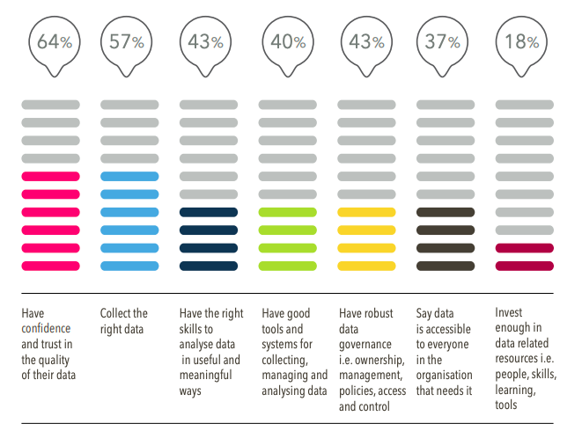
https://dataevolution.org.uk/wp-content/uploads/sites/8/2017/01/Full_Report.pdf

Superhighways is one of a small number of projects in London to receive funding from the Cornerstone Fund, a multi-funder initiative to test how specialist civil society support could be funded in London. City Bridge Trust are funding Superhighways to lead on delivery of this new initiative.

Kate White, Manager, Superhighways:
“Data doesn’t have to be a scary word for small organisations: data can help charities determine where problems lie, solve them more efficiently, influence policy and unlock community potential to create and deliver services that meet local people’s needs.
Our partnership will ensure that small social impact organisations aren’t left behind by their large charity or commercial counterparts by giving them access to the quality training, advice and specialist support they need to develop their data skills and knowledge, underpinned by strong digital capability”.

Dr Natasha Codiroli Mcmaster, Data and Intelligence Coordinator, London Plus:
“London Plus are very excited to be involved in this fantastic initiative to help charities in London harness data more effectively.

There are a vast number of open datasets and surveys that are not being used fully by London’s civil society sector. Charities can bring unique insights to the analysis and interpretation of this data through their on the ground knowledge and experience. Charities also collect a huge amount of data that could help complement insights from larger scale surveys, reaching groups often missed from government datasets.”

Giselle Cory, Executive Director, DataKind UK
“Responsible, informed data use can transform the impact of small charities, answering big questions - like who is using the charity's services and what works and what doesn't, and where there is unmet need. But using data well requires staff and volunteers to be confident in their abilities to make responsible use of data - which can be a challenge in small organisations that don't have resources to invest. This programme will help those organisations build their know-how and confidence, and ultimately increase their impact.”

Christine Goodall, Coordinator of the HEAR Equality and Human Rights Network:
“Using digital tools is becoming increasingly important for voluntary and community groups of all sizes, and is increasingly expected by funders and others with whom they engage. However, it is vital to recognise the differing capacities, skills and access needs involved.
HEAR is delighted to be a partner in this new project. We will be helping to make sure that groups using digital means to assess and report their impact can do so in a way that is as accessible and inclusive as possible.”

Antonia Orr, CEO, Coalition for Efficiency:
“Any data or digital strategy should be underpinned by a clear understanding of the impact an organisation is seeking to achieve. For small organisations with limited resources, it is even more important to ensure that their approach to collecting, interpreting and using data is practical, proportionate and effective.
As part of this partnership, we look forward to helping leaders reflect on how they measure and manage the impact of their organisation’s work in order to meet the needs of those they exist to serve.”

Matt Kepple, CEO, Makerble
“People in the communities served by charities deserve the best that we have to offer. In order for us to give them our best services, we need time where we're not rushed off our feet and insight on hand that can shape richer ideas. Digital technology gives us that. It gives us greater control, security and efficiency which means that processes that would take hours and days can now happen in seconds and minutes.
We can use that spare time and head space to spend more time focused on the communities we care about. And we can use the trends, insights and reminders that would be difficult to find in paper-based systems, to make our services, programmes and campaigns more effective and impactful. At Makerble we look forward to supporting charities and social enterprises to making this transition towards data maturity”.

Find out more and let us know how you are supporting the small charity sector with their use of data: https://superhighways.org.uk/training-advice-and-technical/data-skills/

ENDS

Notes to editors:
Superhighways offers advice, training and IT support to help small charities and community organisations across London be more effective, raise their profile and demonstrate their impact using digital technology. Superhighways is the only non-profit in London focused solely on the use of digital technology in community organisations in London’s local civil society. It is part of the charity Kingston Voluntary Action.
Call Kate White / Sorrel Parsons 0208 255 8040 or email info@superhighways.org.uk
London Plus is the new hub for civil society support in London. A small team of 5, they support London’s Volunteer Centres and other volunteer brokerage agencies, facilitate the London CVS Network with a current focus on data and intelligence, employment and skills.
DataKind UK brings together top data scientists from cross sector backgrounds with leading social change organizations to collaborate on data projects that maximize social impact. Pro bono data scientists provide the help charities often need to tackle critical humanitarian issues in the fields of education, poverty, health, human rights, the environment and cities.
HEAR Equality and Human Rights Network is a pan-equality network of London equality and human rights voluntary and community sector organisations. HEAR connects and supports equalities specialists across all equality characteristics in London to get their voices heard, influence policy, reduce discrimination and improve access.
Coalition for Efficiency help small charities and social enterprises focus on maximising their impact. It’s flagship programme, Measuring the Good, is designed as a practical and structured approach to help organisations embed a culture of impact management in order to improve their performance, learning and be effective in how they serve their communities.
Makerble platform combines the flexibility of a powerful database with the intuitive familiarity of a social media platform. Makerble provides an impact app and CRM that can simplify monitoring and evaluation, reducing the time charity staff spend on impact reporting.

