
Excel Bitesize 1 – Managing your data with Microsoft Excel
Contents
Working with Excel 3
1. Understanding the Ribbon 3
2. Getting help 3
3. Correcting mistakes 4
4. Different Versions of Excel 4
Viewing Spreadsheets 5
5. Format tabs 5
6. Freeze panes 5
7. Unfreeze panes 6
8. Hide columns 6
9. Unhide Columns 7
10. Resize columns 7
11. Wrap text 8
Managing data with tables 9
12. Make your data into a table 9
13. Naming the table 10
14. Formatting the table 10
15. Adding a Total column 11
16. Adding a Row Total 12
Sorting & Filtering 13
17. Sorting (Single level) 13
18. Sorting (Multi-level) 14
19. Clear sort order 15
20. Filtering (Select & Deselect) 16
21. Filtering (Text filters) 17
22. Data Slicers 18
Printing 20
Exercises 21

Working with Excel

Understanding the Ribbon
It really helps to get to grips with the Excel terminology as it makes like a lot easier to find things & understand instructions when using the Microsoft Excel help feature or the internet for help.
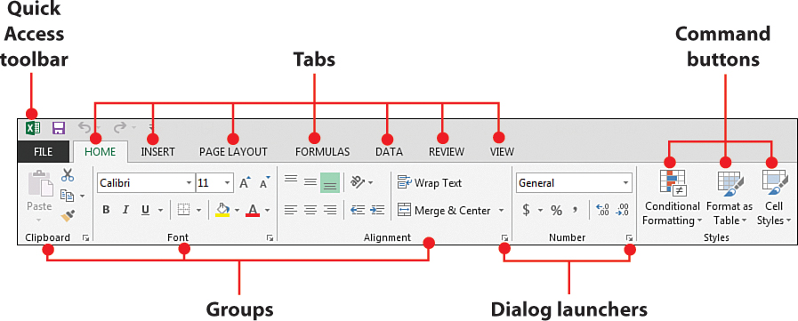
The Ribbon is made up of five basic components: the Quick Access Toolbar, tabs, groups, command buttons, and dialog launchers.
- The Quick Access Toolbar is essentially a customizable toolbar to which you can add commands that you use most frequently.
- Tabs contain groups of commands that are loosely related to core tasks. It helps to think of each tab as a category.
- Groups contain sets of commands that fall under the umbrella of that tab’s core task. Each group contains buttons, which you click to activate the command you want to use.
- Dialog launchers are activated by clicking the small arrow located in the lower-right corner of certain groups. Clicking any dialog launcher activates a dialog box containing all the commands available for a given group.
- Command buttons when clicked launch a macro which perform a specified action in Excel.

Getting help
If you can’t remember where to find a function in Excel, use the search function at the top to get assistance.
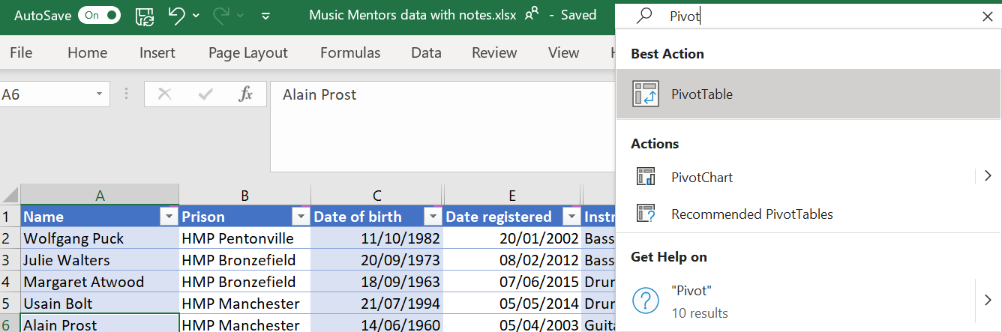

Correcting mistakes
Microsoft Excel tracks all the changes you make to a file, if you make a mistake (or two!) you can step yourself backwards through the changes you made to reverse anything you did wrong.
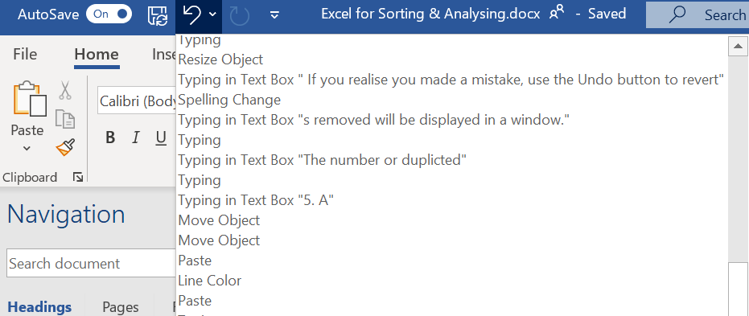
1.Click on Undo arrow to go back a step. You can continue to step back multiple times.

Different Versions of Excel
There are several different version of Microsoft Excel, be aware that different versions offer different features and existing features might be accessed via different means.
These different versions & how they look on a laptop versus a PC means that the screen prints in this document might not always look exactly the same as the screen in front of you. But the features will be there so look for the icons which remain consistent or use the search feature to find them.
Microsoft 365
Make sure you have the latest version of Microsoft 365 (10 free licences if NFP)
Microsoft Office 2016 & Later
You can get buy a licence from charity digital for £33 for Microsoft Office 2019. .
Microsoft licencing is done on a 2 year open licence which means you get upgrades so check before buying anything in case you are eligible for an upgrade rather than paying extra when you want to upgrade to a newer version.

Viewing Spreadsheets
Working with workbooks with large amount of data in each sheet can be very unwieldly. Before starting it’s worth getting your view sorted out so that you can easily move around between worksheets.

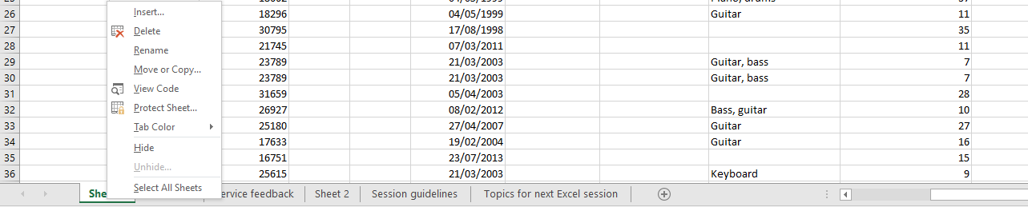
Format tabs
1.Right click on the sheet tab to reveal formatting options: Rename, Move & Tab colour

Freeze panes
Allows you to control areas of the spreadsheet to be fixed as you scroll.
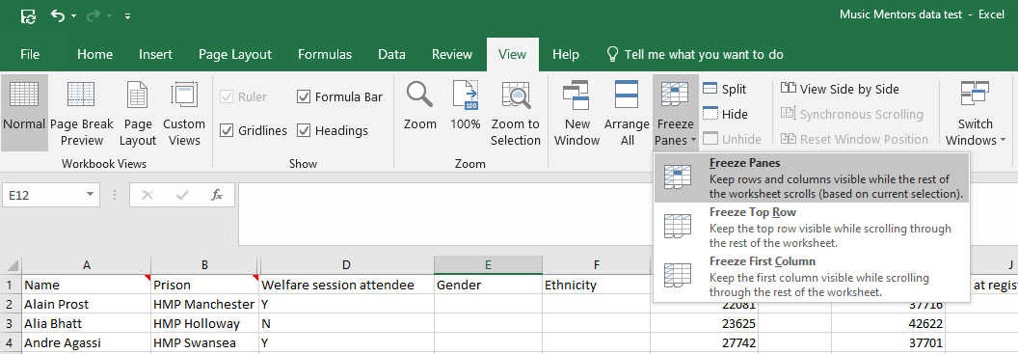
2.Click on the arrow on the freeze panes command button
3. Select how you want to freeze panes
1.Click on the View tab

Unfreeze panes
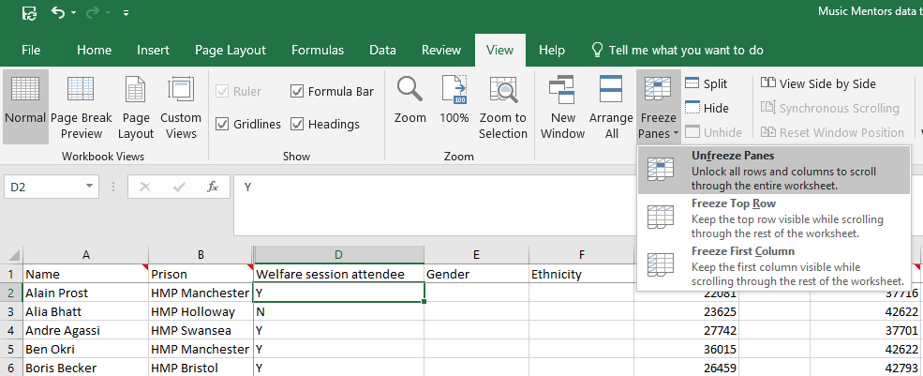
2.Click on the arrow on the freeze panes command button
1.Click on the View tab
3. Select Unfreeze panes

Hide columns
Hiding columns from view can be very useful when working with big spreadsheets so that you only work with the columns you need. 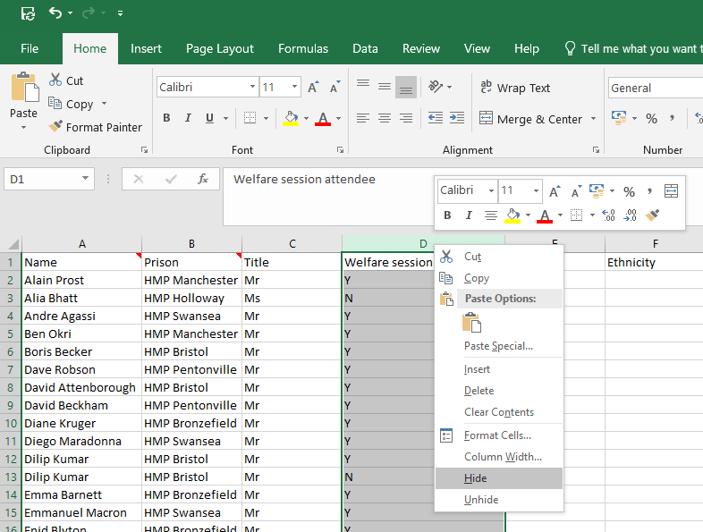
1.Highlight the column you want to hide by clicking on the letter at the top of the column
2.Right click with your mouse and select Hide

Unhide Columns
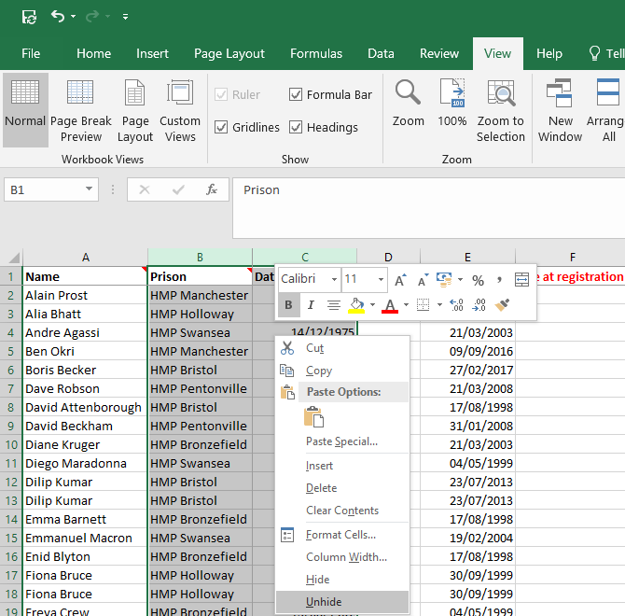
1. Highlight the columns on either side of the hidden column by clicking and dragging across the top of the columns.
2. Right mouse click and select Unhide

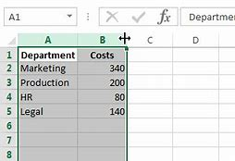
Resize columns
2. Hover with the mouse between columns. When the mouse pointer changes drag the column to the width you want or double click for it to automatically resize.
1. Select the columns you want to resize

Wrap text
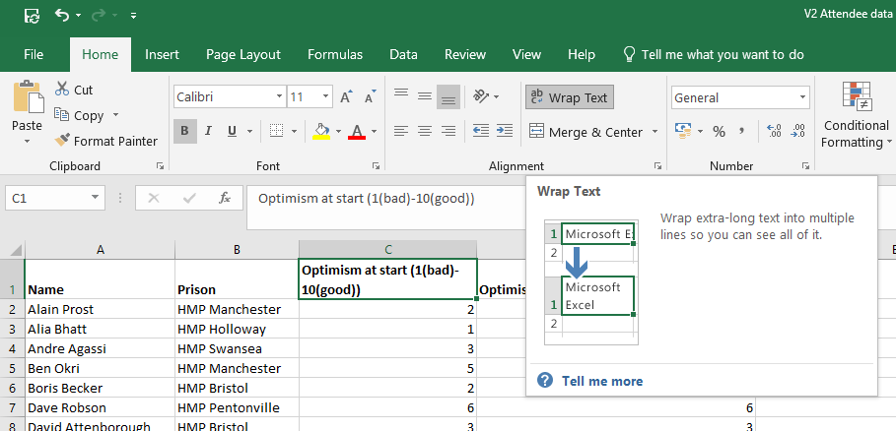
Wrap text allows you to display a long line of text on multiple lines so that it can all fit in one cell.
1. Select the cell where you want to wrap the text
2. Click on Wrap Text

Managing data with tables
The advantages of an Excel table include all of the following:
  - Quick Styles
Add color, banded rows, and header styles with just one click to style your data.
  - Table Names
Give a table a name to make it easier to reference in other formulas.
  - Cleaner Formulas
Excel Formulas are much easier to read and write when working in tables.
  - Auto Expand
Add a new row or column to your data, and the Excel table automatically updates to include the new cells.
  - Filters & Subtotals
Automatically add filter buttons and subtotals that adapt as you filter your data.
  - Dynamic Pivot tables
If you use an Excel Table for the source data of your pivot table, the data range becomes "dynamic". A dynamic range will automatically expand and shrink the table as you add or remove data, so won't have to worry that the pivot table is missing the latest data. When you use a Table for your pivot table, the pivot table will always be in sync with your data.

Make your data into a table
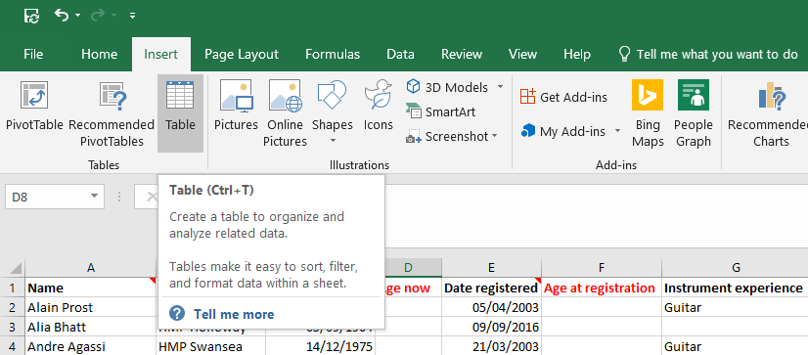
2. Click on the Table command button
1. Click on the Insert tab
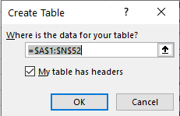
3. A window will open. Confirm the cells to be included in the table and that the data has headers

Naming the table
It is good practice to name the table as it makes life much easier later when working with formulas. Naming the formula is basically giving your data set a name which will enable you to recognise which data set you need to be working with.
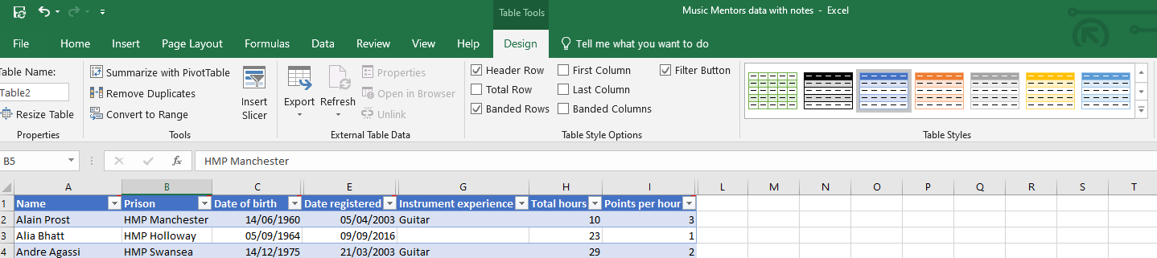
2. Rename the table. For example, “Participants”
1. Click on the table & select the Design tab

Formatting the table
There are a number of table formatting options in Excel. The benefit of the table format is that it ensures each new column or row you add to your table will be automatically formatted in the same way.
Change the look and feel of your table with the formatting tools

Adding a Total column
1. Highlight the cells you want totalled, including the blank cell where the total will go
2. On the Home tab, click on Sum
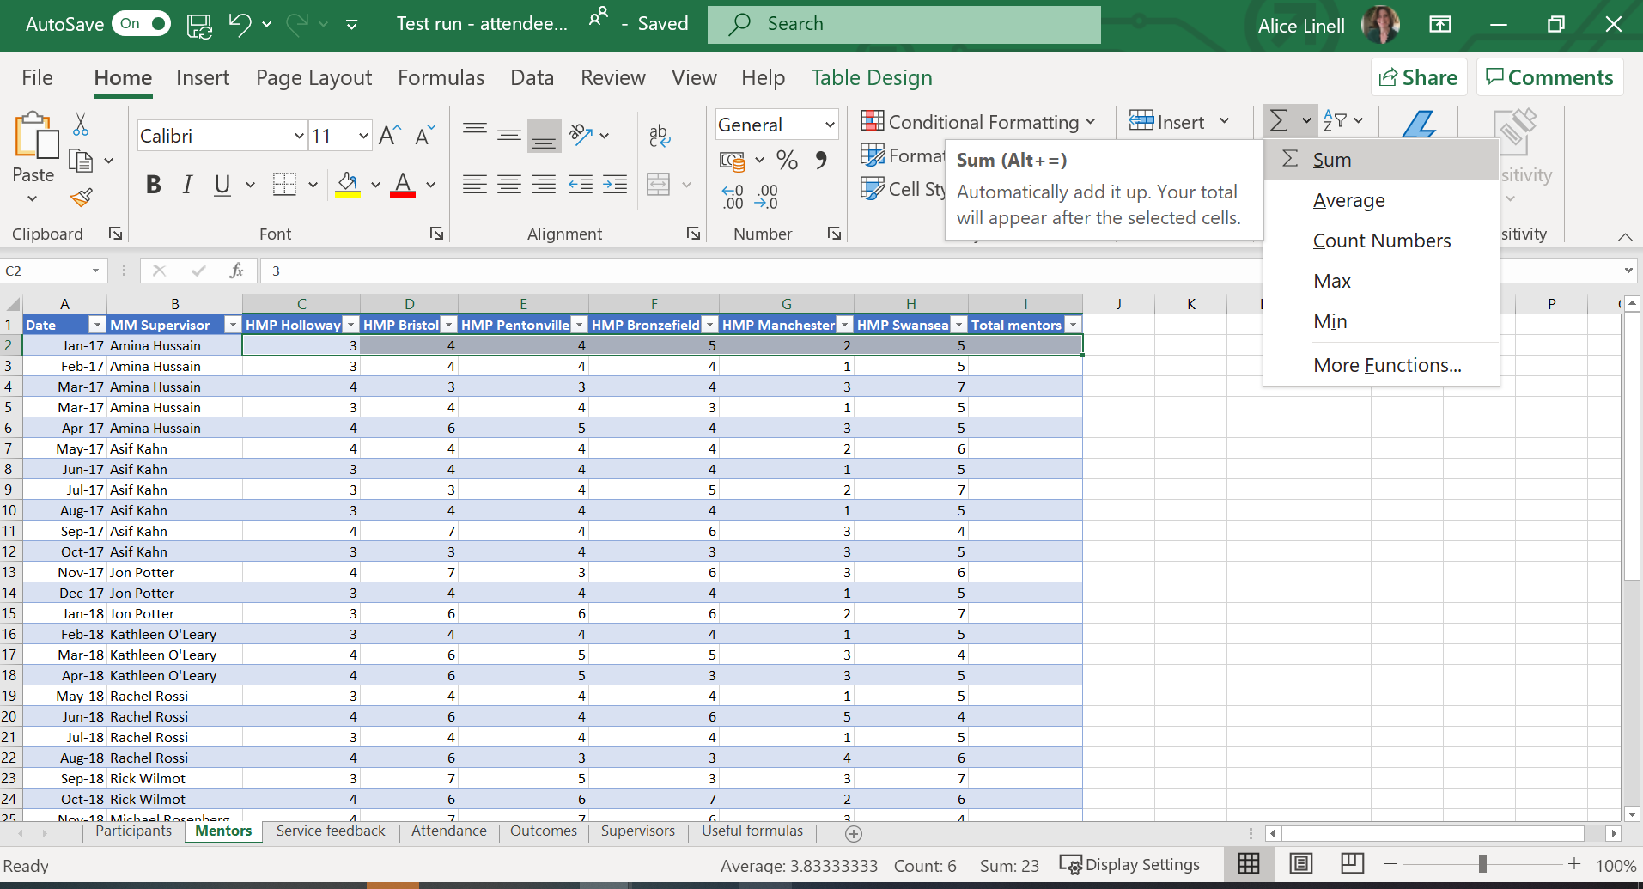

Adding a Row Total
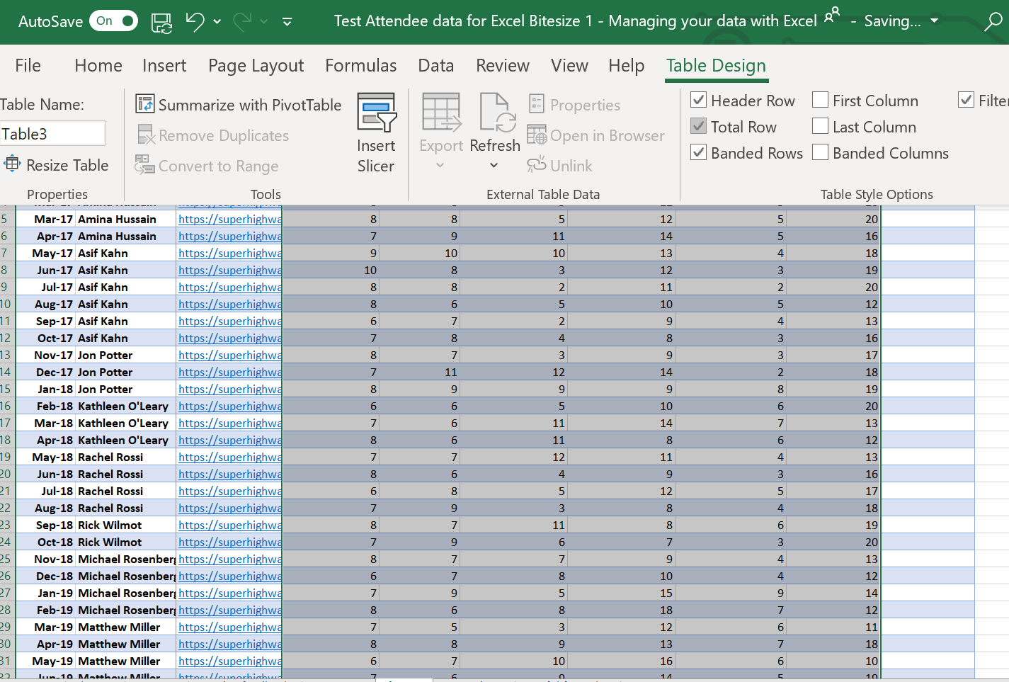
1. Highlight the columns you want totalled
2. On the Table Design tab, check the box Total Row

Sorting & Filtering

Sorting (Single level)
Simple sorting can be done using the options available in each column header.
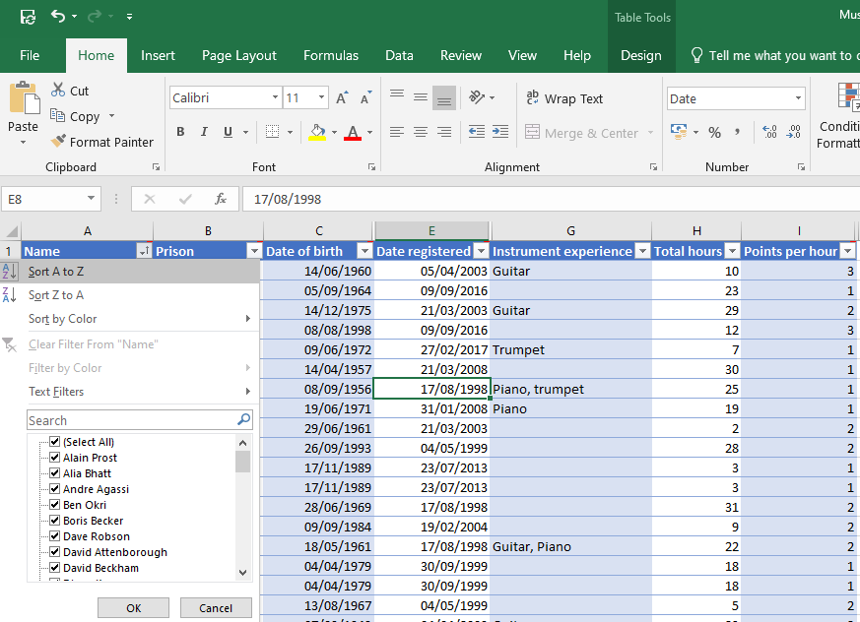
1. Click on the arrow in the column header of the column you want to sort
2. Select Sort A-Z or Z-A for text or Smallest to Largest, Largest to Smallest for numbers & dates

Sorting (Multi-level)
More complex sorting options are available via the Home tab including:
- Multi-level sorting
- Custom sort orders
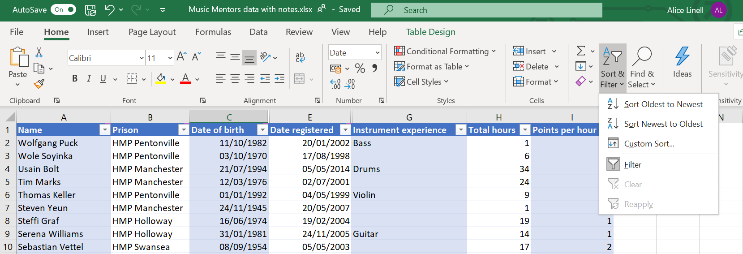
1. Click on the Home tab
2. Click on the Sort & Filter command button
3. Click on Custom Sort
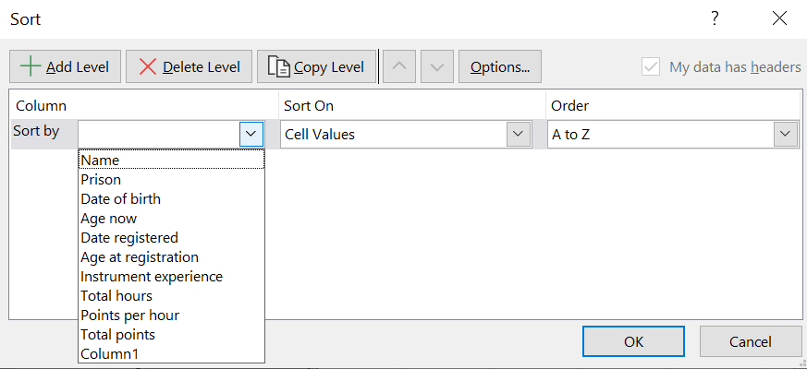
4. A window will open. Select the column you want to sort by, the value to sort by and the sort order for the first level of sorting.

5. Click on OK

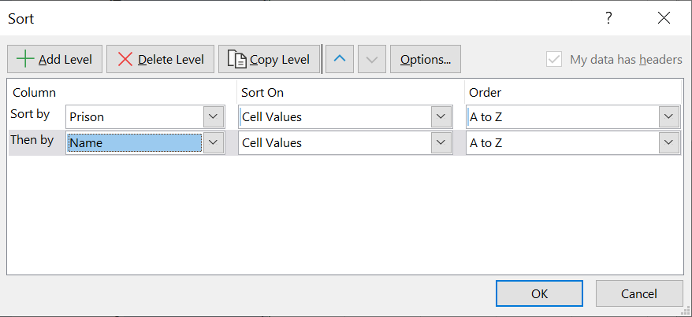
6. Click on + Add level to add a secondary sort level. For example, here we are sorting by prison name and then by participant name.

Clear sort order
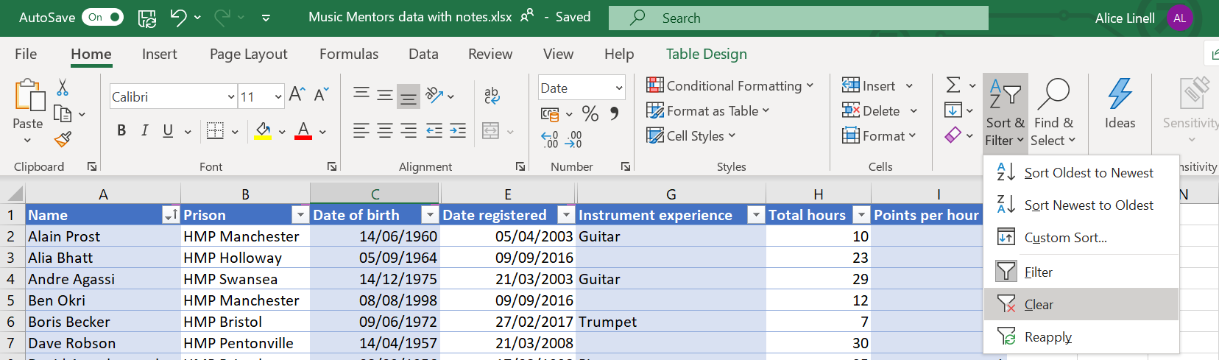
2. Click on Sort & Filter

3. Click on Clear

1. Click on the Home tab

Filtering (Select & Deselect)
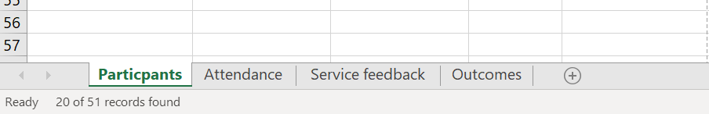
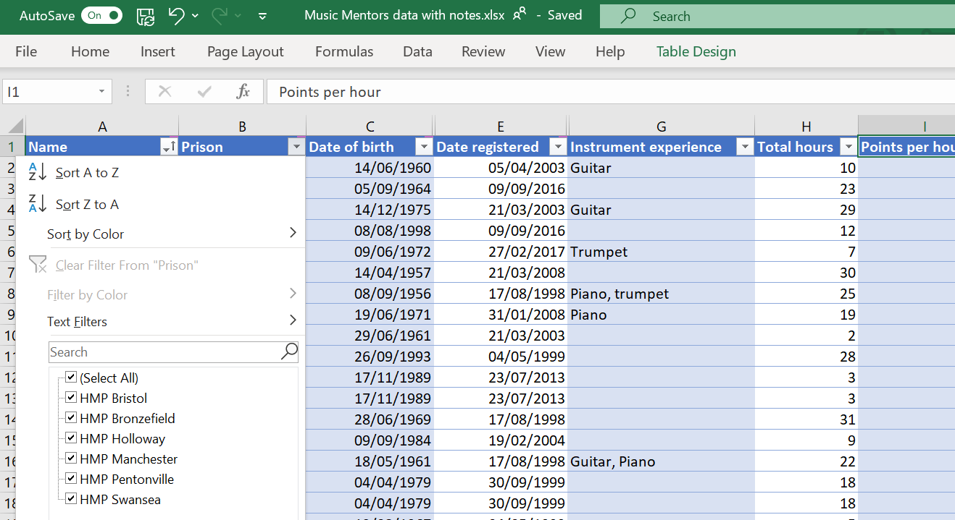
When you have applied the filter, look at the bottom of the sheet to see the total count of the filtered rows.

2. Select the values you want to filter by

1. Click on the arrow next to the column header of the column you want to filter by

Filtering (Text filters)
Excel has more advanced filtering options available via text filters:
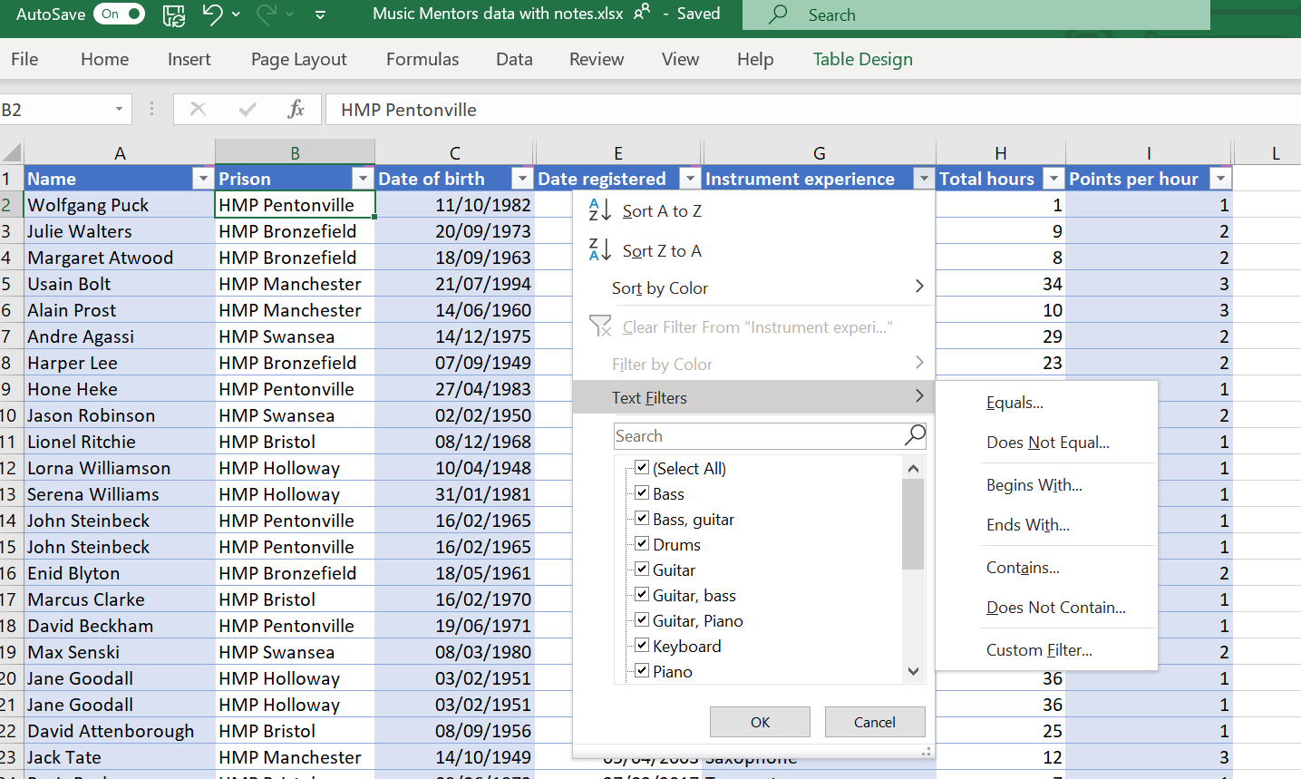
1. Click on the arrow next to the column header of the column you want to filter by

2. Select Text Filters

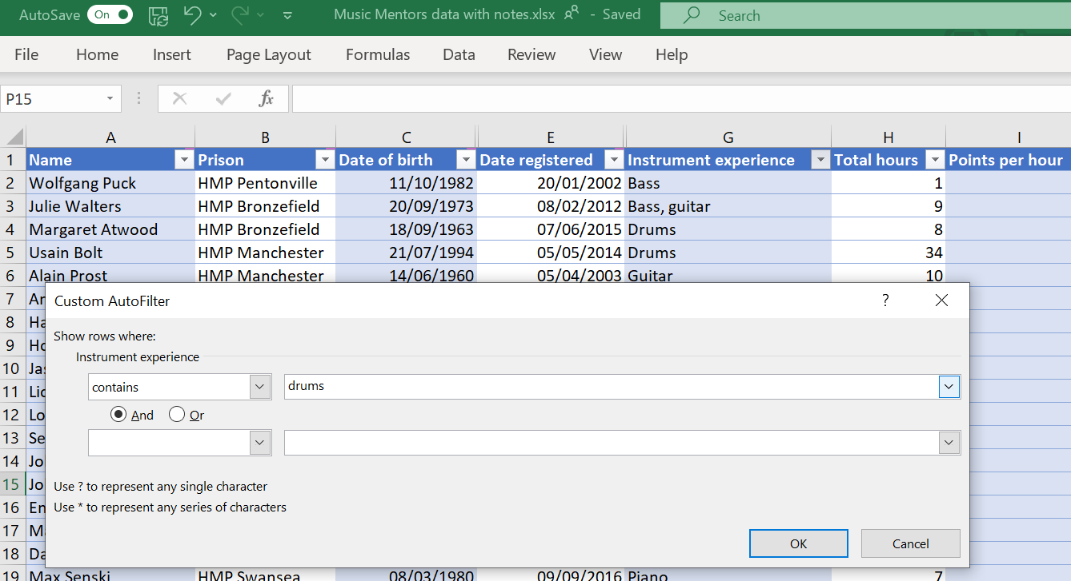
5. Enter the value you want to filter by

4. Check the filter type correct

3. A Custom AutoFilter window will open.

Data Slicers
Slicers are visual filters. Using a slicer, you can filter your data (or pivot table or pivot chart) by clicking on the type of data you want.
1. Click on the Insert tab

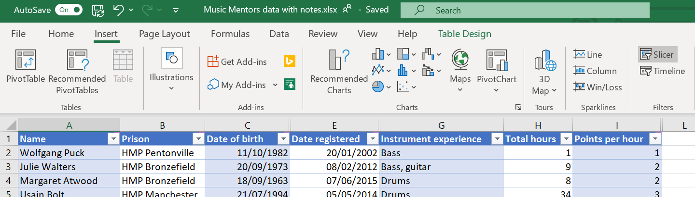
2. Click on Slicer

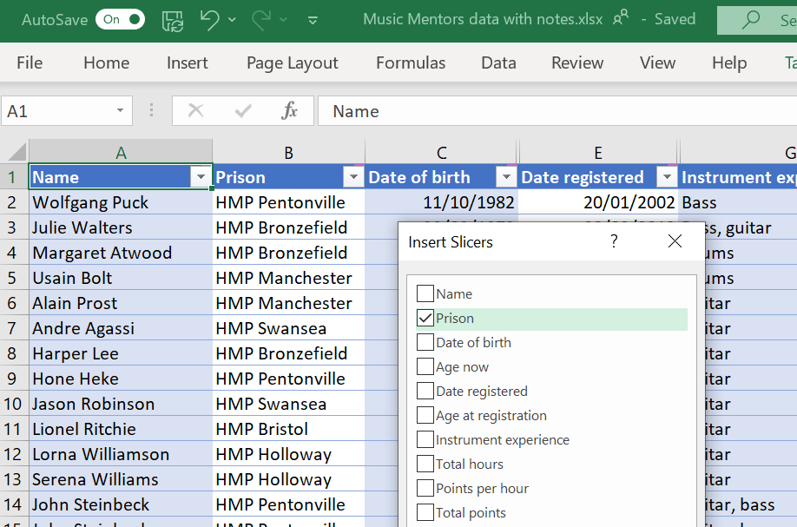
1. Insert Slicer window will open.

2. Select the column(s) you would like to use for filtering

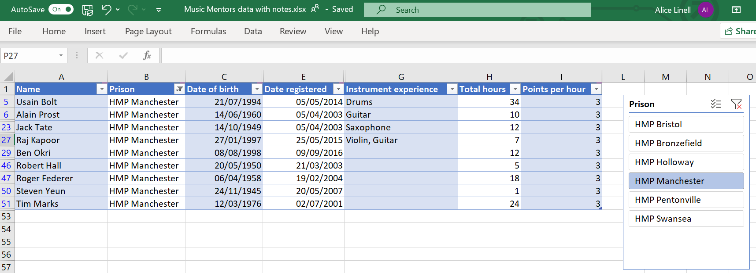
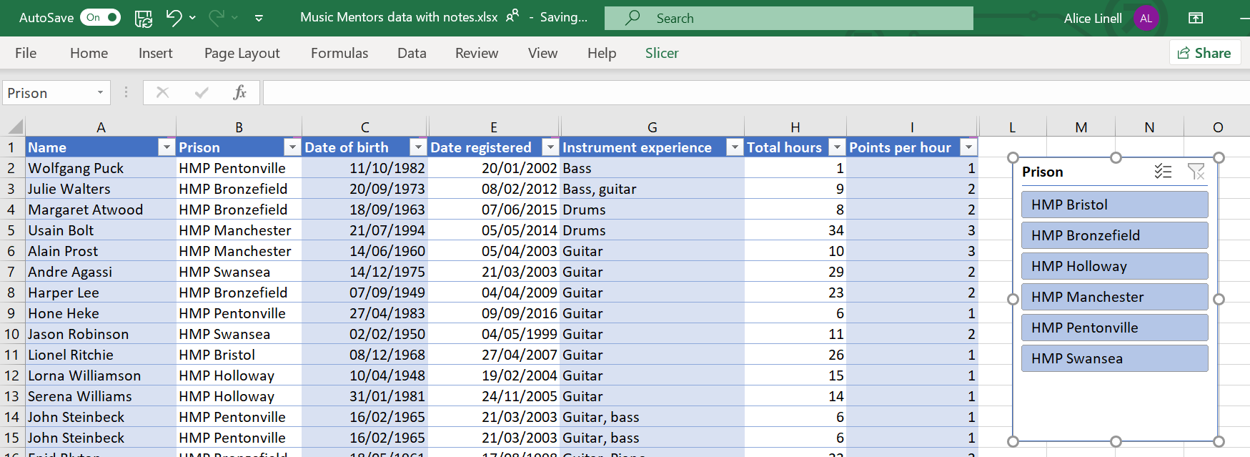
4. Select a single filter option to apply the filter
3. Drag and drop the slicer to the location you want

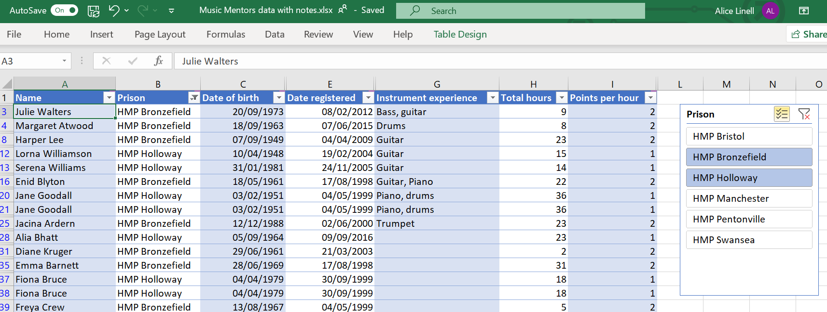
5. To add more than one filter click on the Multi-Select button
6. Select multiple filter options to apply

Printing
In the print preview screen you can review your data before printing it.
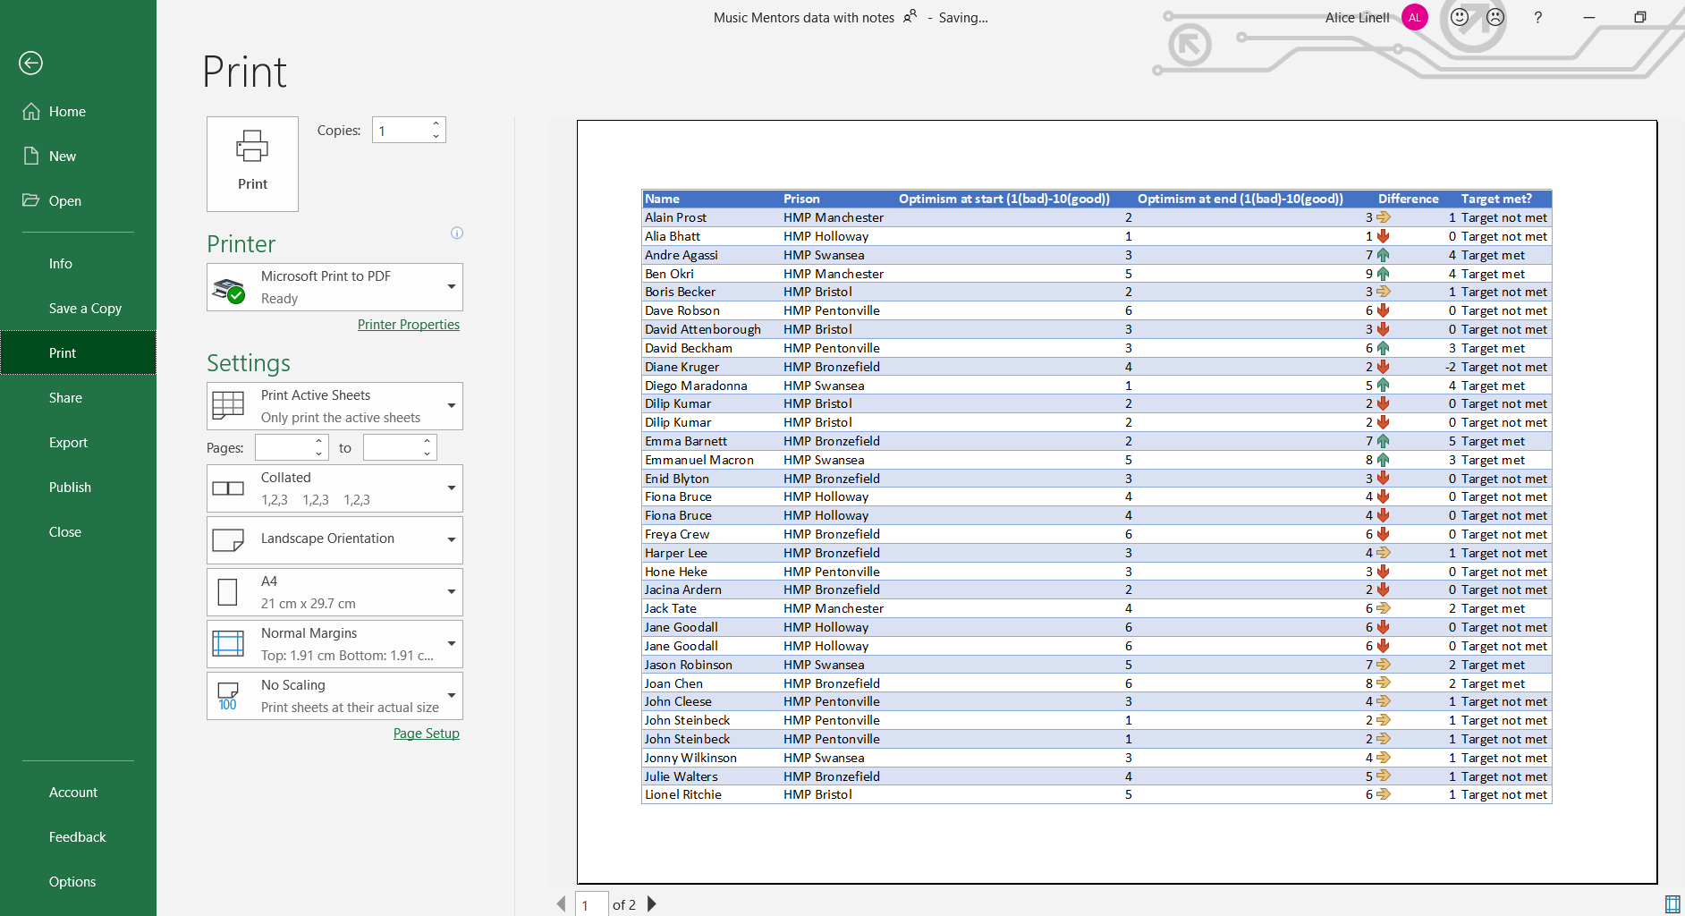
Select Page Set Up to add headers and footers to pages

Scaling allows you to fit all the columns and rows on one page

Make sure the orientation is correct for the data set

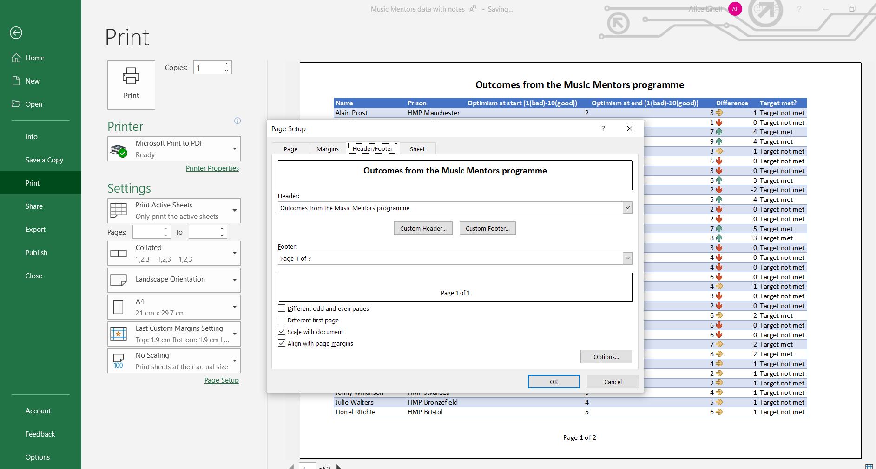
Select Header/Footer to add in automatic or custom headers and footers

Exercises



