PowerPoint exercise list
I will demo each section. Please watch in the Zoom screen before starting each exercise.
PowerPoint ribbon
Create a presentation (starting from scratch, we will look at themes later)
- Open PowerPoint
- Create a new ‘Blank presentation’ (you may need to go to File and New). This will automatically create a presentation with a title slide.
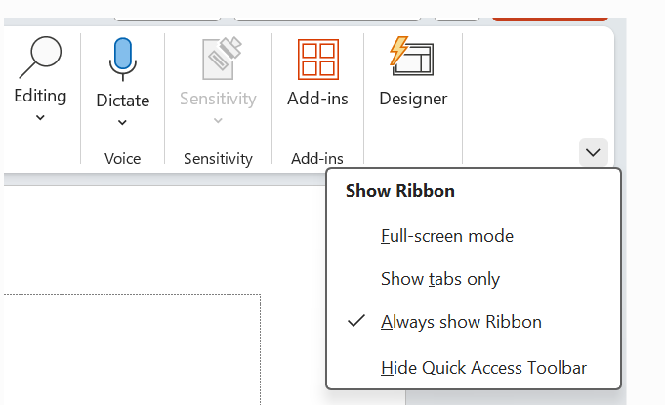
- Check that you can see your ribbon. If you can’t see your ribbon, click on any tab and go to the little arrow in the right corner and click on ‘Always show Ribbon’

- Click in the text boxes to change your title and subtitle
- Save your presentation

Inserting a content slide
- Go to Insert on the ribbon and New Slide
- Insert a Title and Content slide and a Picture with Caption Slide
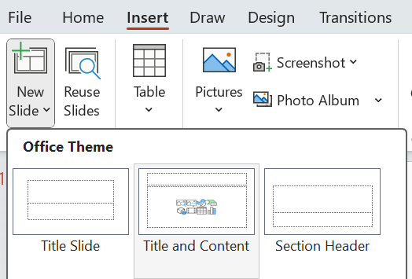
- Duplicate one of your slides (right click or Control and D)
- Rearrange your slides into the correct order
- Save your presentation
Don’t forget to regularly save if your system is not automatically saving it for you. The file location and your IT set up will determine this.

Adding and editing text
Let’s create a 5-slide presentation about your organisation or one of its projects. Feel free to make this up. You can come back to it later.
- Change the font size and colour of your title and subtitle
- Re-size and align your text if needed
- Add a title and 3 -6 bullet points to your Title and Content slide about why your organisation is brilliant
- Change the colour and style of your bullet points.
A recommended font size for body is 24pt.

Adding photos
- Add what your organisation does (a brief description) and a photo to the Picture with Caption Slide
- Add an Online photo
- Check the Alt Text
- Now upload a photo and add your own Alt Text
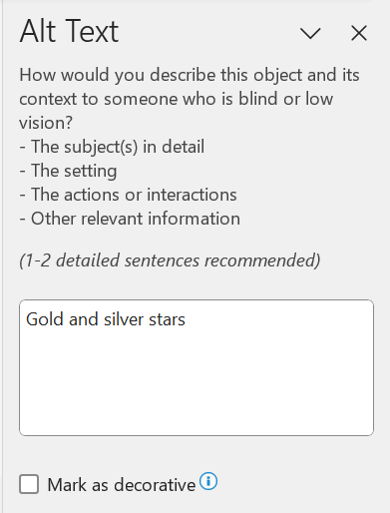
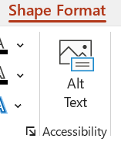

Inserting a screenshot
- Add a new Blank slide
- Go to Insert a screenshot of your website (or any website)
- Crop the screenshot

Insert an icon
- Insert a new slide and add an icon, then resize
- Have a look at the other icon and image options in your library

Insert a shape and rearrange layers
- Insert a shape and change its colour
- Insert a text box and add some text (resize and colour as needed)
- Arrange your layers by sending back or bringing forward, either under Shape Format (or by going to the Home tab and Arrange).
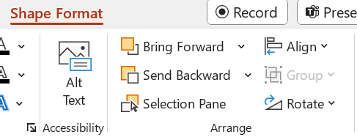

- Go to the Home tab and select your items (either individually hold Ctrl and click or click, hold and draw a select area)
- Then Arrange and Group your items
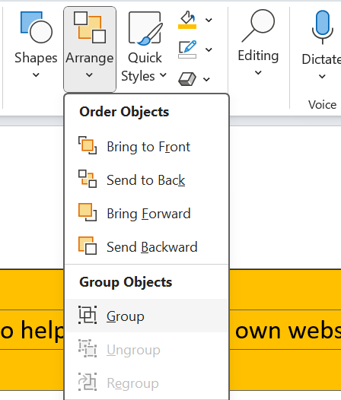

Themes and design
- Click on your Title slide*
- Now go to the Design tab
- Choose a theme if you like
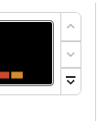
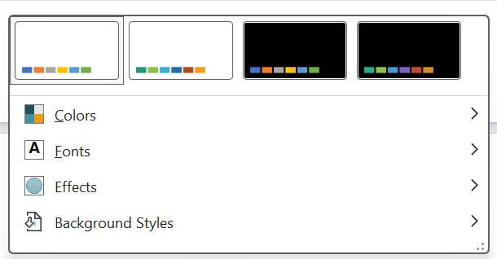
- Choose a font variant (use the little drop-down arrow by Variant)

- Customise your colours if you have time
- If you have access to Designer, click on different slides in your presentation to see the options. Be careful to keep your slides in the same ‘family’ of styles otherwise your presentation will look messy and inconsistent.

*It’s important to go back to the Title slide before making changes as this will then apply your new style choices to the whole presentation, not one particular slide.
If you were to duplicate this whole presentation again, it would retain the styling. However, for staff and volunteers you may wish to create a copy of your presentation, delete the details and add placeholder text. Then save as a template.

Speaker notes and controlling what you show on screen

- Add speaker notes to one of your slides
- Consider what you’d need to say. Your slides should not be notes, but aides to helping you speak.
- Hide a slide
You can also add your notes as additional slides that are hidden when you present but shared afterwards or create a Custom Slide Show.

Presenting
- Go to Slide Show
- Untick Use Timings
- Go to the Slideshow tab
- Present your presentation from the beginning. Is there anything you would change?

Saving as a template
- Go to File and Save As a template .potx file
- You can add placeholder text to your template and save later (delete out what you have and add prompts for your team
- Now you can re-open your presentation and keep working on it

