
Introduction to Excel – Session Exercises

Topic 1 - Formatting

Part 1
- Make the Introduction tab Red (right click and select Tab colour)
- Rename Sheet 1 to Participants (double click or right click, choose rename and then type in the new name)
- Move the Participants sheet to after the Mentors sheet (click on the tab and drag to new position)
- In the Participants sheet, make the column headings bold (select the top row and Bold in the Home tab)
- Align the Welfare session contents left (highlight the column and choose left alignment in the Home tab)

Part 2
- Hide the Sentence start date column (highlight the column, right click and select Hide)

- Wrap the text in the Musical experience column (highlight the Musical experience column and click on the wrap text icon (abc with curved arrow ) in the Home tab)
- Resize all the columns so that they are as wide as the column contents (click on the triangle in the top left to select the whole sheet. Now double click on the boundary between two columns)
- Freeze the top row of the Participants sheet (go to the View tab and select Freeze panes and top row)

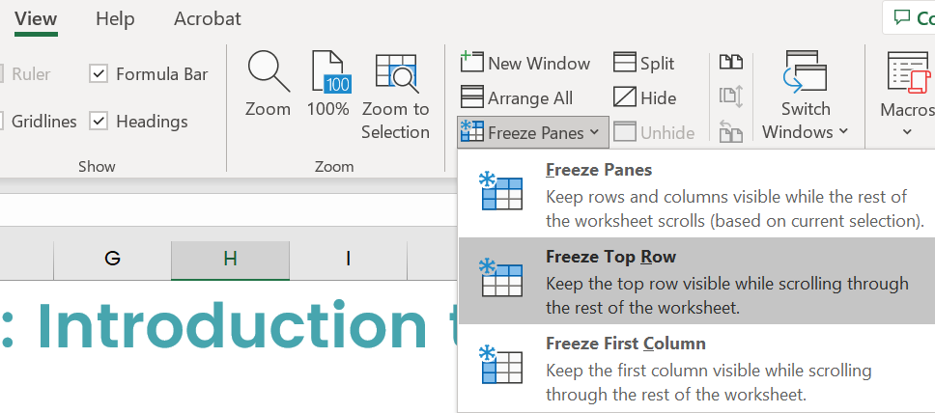

Topic 2 - Sorting
- Still in the Participants sheet, sort the Welfare attendance column alphabetically A to Z (highlight this column, go to the Data tab and Sort)
- How many participants are yet to have a Welfare session?
(click and drag to select cells containing N. Look at Status Bar – bottom right for Count:XX)

- Now sort your worksheet by Prison and then by Musical experience (first select Prison and then Add a level and select Musical experience)
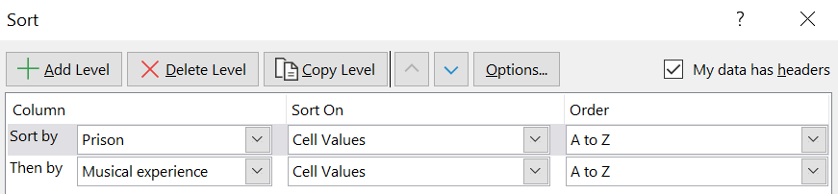
- Which participant is in row number 4?
- How many participants in Pentonville prison have no prior musical experience?
- Now sort by Sentence start date only (delete existing Sort levels)
- Which prison has the participant with the most recent sentence start date?

Topic 3 – Auto formulae
- In the Mentors sheet, switch on Freeze panes so the first row and first column don't scroll (Find Freeze panes in the View tab and select the top option)

- In the Total Mentors column, use Auto sum to calculate the total number of mentors in Jan 17 (Click in the cell and select the Auto sum icon on the Home tab. Check the correct data range is highlighted. Press Enter on your keyboard)
- How many mentors in total participated in Jan 2017?
- Which month and year had the most mentors participating? (Copy the formula down to calculate for each row)
- Use the Average function in cell C40 to calculate the average number of volunteer mentors participating in HMP Holloway. What was the average number of volunteer mentors?
- Copy the formula across to see the average for each prison.
- Which prison has the highest average number of volunteer mentors participating in sessions? What is this number?

Topic 4 – Basic manual formulae

- Add a column with heading ‘Expenses unit cost’. Add £3.50 into the first cell and change format type to Currency (Check Currency is selected from the drop-down list of options in the Home tab, Number grouping - towards the middle of your menu bar) Now copy down the contents to all rows beneath.
- Now add another column with heading Expenses total. Add a formula to calculate this multiplying the unit cost by the number of mentors Now copy the formula down.
- What are the expenses costs in Dec 2018?
- What are the total expenses paid out across the 3 years - 2017, 2018 & 2019? (Use Auto sum function in cell K40 to add up expenses for each month)

Topic 5 – Printing tips
- On the Attendance sheet, use Auto sum to calculate the total number of participants in Jan 2017. Copy the formula down
- Now select Print
- Using the Scaling options at the bottom, select the Fit Sheet on One Page option
- Now change the page orientation to be Landscape
- Now click on the Page Setup link at the bottom (underneath the Scaling options)
- Give your sheet a title Music Mentors Attendance by going to the Header/Footer tab and clicking on Custom Header. Add to the middle section.
- Now go to the Sheet tab (again after clicking on the Page Setup link) and select to show Gridlines when printing.

