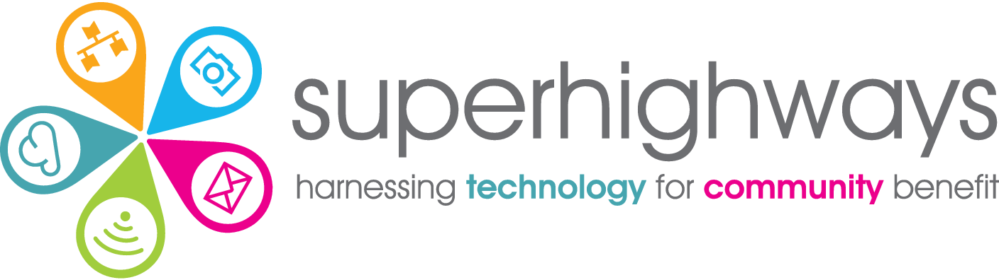

Digital Foundations programme, 2024

Fit for purpose tech and digital infrastructure healthcheck & checklists

About your organisation 1
Files & data 1
Email & other digital comms 2
Other digital tools / platforms used? 3
Managing tech (including digital and skills levels) 3
Cyber security 4
Data protection 4

About your organisation
- What’s the mission of your organisation and key services / activities delivered.
- Who are your beneficiaries – do they have any particular digital inclusion / accessibility needs? Are you supporting local people e.g. in a neighbourhood or borough. Or are you working across a wider area e.g. sub regional or pan London?
- What’s the structure of your organisation e.g. registered charity etc
- When did your organisation start? How established are you?
- What’s your annual income? And who are your funders?
- How many staff, volunteers and trustees do you have?
- What’s your working environment? Do you have one or more office bases? Do you have a hybrid working model – some people working from home / remotely some or all of the time etc? Do people use personal or work devices?
- Are your services and activities delivered in person, online or a mixture? Do you deliver any ‘digital services’ If so what?

Files & data
- Where do you store your organisational files – word docs, excel spreadsheets etc
- Are these accessible to everyone? Or have you set different access / permission levels? If so how?
- How do you collaborate on documents e.g. policies, minutes, funding bids etc? Do you send as attachments and manage multiple versions? Do you work together on live online documents?
- Do you share files externally with e.g. partners, users etc If so how?
- Do you have a back up of these files in case of e.g. file corruption, loss / theft of a device etc If so what?

Key challenges you’d like help with?

What would good look like?

Email & digital comms
- Do you have an organisational domain name (e.g. superhighways.org.uk ?) If so – do you use for your website? Do you use for your emails? If not – why not?
- If you have a domain name do you know where is this registered? Do you have access / control of this? Do you know which email address is listed for updates e.g. domain renewal
- What email facility do you use? Does everyone have their own email or are some accounts shared? If so how?
- Do you have a website? If so what platform are you using? Is this just for information or is it an interactive site e.g. people can sign up for activities, do you have a Webchat service etc
- What other digital comms tools do you use for keeping in touch internally and with external stakeholders and users? Please add in specific tools you use and any costs
  - Online calls e.g. Zoom etc
  - Online chat e.g. Teams etc
  - Newsletter e.g. Mailchimp etc
  - Messaging apps e.g. Whatsapp
  - Social media – Twitter, Facebook, Instagram, YouTube, TikTok etc
  - Video / audio content creation e.g. Adobe spark, YouTube etc
  - Design tools e.g. for posters, annual reviews & social media images
  - Analytics e.g. Google Analytics

Key challenges you’d like help with?

What would good look like?

Other digital tools / platforms used?
What other platforms do you use to underpin your work? Please add specific tools, what you use these for and whether you pay for any or make do with free versions?
- Video calls / online sessions e.g. Zoom, Teams, Meet etc
- Date scheduling
- Appointment / calendar booking
- Event booking
- Contacts management
- Case management recording
- Attendance monitoring
- Online forms & surveys e.g. for registration forms / satisfaction surveys
- Data analysis / visualisation tools
- Automation / integration tools e.g. PowerAutomate, Zapier etc
- Project management / productivity tools e.g. ToDo, Trello, Planner etc
- Other collaboration tools e.g. Jamboard, Miro, Whiteboards etc
- Accessibility tools e.g. screen readers or inbuilt browser translation tools etc
- Other custom digital service delivery tools

Key challenges you’d like help with?

What would good look like?

Managing tech (including digital skills levels)
- How do you manage your tech & digital infrastructure? Do you have external support? Is this written in formally as part of someone’s job role? Or does a trustee or volunteer lead on this?
- Do you have a file where you document the tech you use and note e.g. key renewal dates, costs, passwords etc useful for reference particularly when there is turn over of staff Do you know the full costs of your tech / digital usage? How do you fund this? Do you access the charity discounts available?
- Do you have relevant tech / digital policies and procedures in place e.g. at induction, exit checklists etc
- What are the general digital skills levels across the organisation? Does the team lack skills needed fulfil their roles? Do you require digital skills as part of the JD / PS? Are there any particular digital skills your team is lacking at the moment?
- How digitally savvy are your trustees? Does someone lead on digital? Are leaders aware of the Charity Digital Code? Charity Digital Skills report etc?

Key challenges you’d like help with?

What would good look like?

Cyber security
The National Cyber Security Centre recommends small charities focus on the following 5 areas to ensure they are taking necessary steps to protect their systems, data and people.
- Back ups (see above in the Files section) Additionally if you are using other tools e.g. a database or website – do you know if there is a back up? Do you understand any limitation of this? Do you know what to do in case you need to restore
- Anti virus and malware – do you have this in place and is it updated routinely and regularly?
- Phishing – are all staff, trustees & volunteers aware of the dangers of phishing and related scams and do they know what to look out for and how to report an attempted or actual incident?
- Passwords – do you have a password policy to ensure robust passwords are used across the organisation Do you use Multi Factor Authentication where available across the tools / systems you use? Do you have individual user accounts?
- Securing your devices – do you have appropriate security measures in place e.g. pin numbers, encrypted laptops, ability to block access. Are your devices up to date e.g. ‘current’ operation system versions with automatic updates switched on.
- Do you need to consider getting the Cyber Essentials accreditation (sometimes required by funders / for other accreditations or quality marks?

Key challenges you’d like help with?

What would good look like?

Data protection
In addition to your responsibility to secure the data you hold (see above section),
- Do you process personal data (data about and which identifies living individuals)? Do you process Special category data e.g. which requires additional
- Is everyone in your organisation aware of the importance of data protection (protecting individuals you are working with) and compliance with relevant legislation e.g. UK GDPR?
- When you collect data do you set out the purpose for which you are collecting, storing and using this data (processing)? Do you have a Privacy policy or Statement? And have you agreed the legal basis for which you are processing any data e.g. does it require Consent? Or do you
- Have you checked whether you need to register as a Data controller with the Information Commissioners Office (there are exemptions for charities / community groups – please check here). Have you a designated lead for all things data?
- Do you have a Data protection policy? Do you understand your responsibilities re reporting a data breach?

Key challenges you’d like help with?

What would good look like?

