
Data analysis session (CAR)

Exercise sheet

Topic 1 - Sorting
- In the Participants sheet, sort the Welfare attendance column alphabetically A to Z
(Click on the down arrow in the table header row for this column)
- How many participants are yet to have a Welfare session?
(Click and drag to select cells containing N. Look at Status Bar – bottom right for Count:x) [11]
- Now sort your worksheet by Prison and then by Musical experience
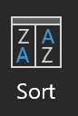
(Go to the Data tab and select the Sort function.

Select Prison and then Add a level and select Musical experience)
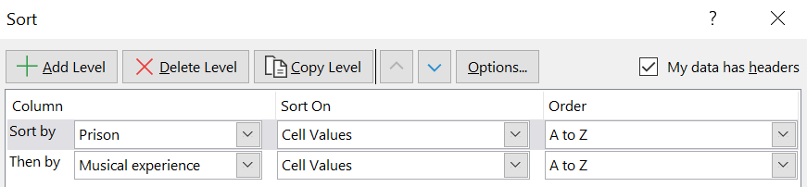
- How many participants in Pentonville prison have no prior musical experience? [2]

Topic 2 – Filtering

In the Participants sheet

Part 1
- Add a filter on the Enjoyed the sessions column to only show records where people ‘Really enjoyed’ the session.
- How many participants Really enjoyed the sessions? [9]
(Look at the bottom left and you should see Found x of y records)
- Now also filter on those who also ‘Enjoyed’ the sessions
- How many people ‘Really enjoyed’ or ‘Enjoyed’ the sessions? [32]
- Clear the Filter from the Enjoyed the sessions column

Part 2
- Add a text filter on the Instrument experience column so that only rows which contain the word “guitar” are displayed.
- How many people have experience of playing the guitar? [13]

Topic 3 – Pivot Tables

Using the Survey responses sheet

Part 1

- Insert a Pivot table (Insert tab and select the PivotTable command)

- Select the following in the PivotTable Fields list on the far-right of your screen: Prison ID, Prison, Enjoyed the sessions (If you don’t see these options, make sure you have clicked somewhere in the PivotTable on the left)

- Drag ‘Prison’ to Rows; drag ‘Prison ID’ to Values; drag ‘Enjoyed the sessions’ to Columns.
Check the Values is showing as ‘Count of Prison ID’.
If not, click on the drop down arrow next to it and select Values field settings and then choose Count as below.
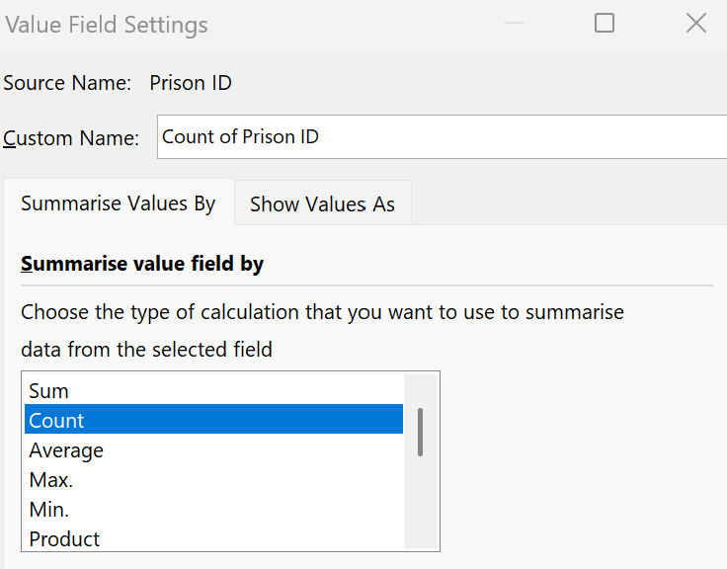

Part 2

- Now change the Value Field Settings to show as % of Row Total (Click on the down arrow next to ‘Prison ID’ in the Values quadrant and choose % of Row Total from the ‘Show Values As’ tab)

- Create a Pivot chart – choose Stacked column chart type

Additional exercises

Extra exercise – Looking at change
- In the Survey results sheet, add a calculation in the Change column (Column I) to show the change in Optimism scores =H2–G2 (the formula should automatically copy down)
- Create a new PivotTable and call it Changepivot
- Select Prison ID, Prison and Change in the PivotTable fields and drag Prison to the row and Change to the column quadrant, with Count Prison ID in the Values quadrant
- In the PivotTable, click on the Column label arrow and reorder AtoZ
- Now create a bar chart showing the distribution of Change scores across the Prisons
- Now filter the chart to just show the 4 prisons beginning with B
- Which prison looks to have achieved the best results in terms of the Change in optimism? Which prison has comparatively not done so well?

Summary Sheets

Using the Summary Sheet

Part 1 – adding Enjoyment data to the Summary Sheet

- Create a Get Pivot Data formula in the top cell of the Enjoyment Column (for Belmarsh Prison) by clicking in the cell and entering =

- Then move to the Enjoyment Pivot Sheet (see Sheet tabs at the bottom) and click on the cell with the results for Belmarsh prison and ‘1 Really Enjoyed’. Now click on the + sign and click the cell with the results for Belmarsh prison and ‘2 Enjoyed’. Press Enter.

- What is this percentage?

Part 2 – copying this formula to remaining rows

- Copy the formula down to the next cell and change the Prison Name to “HMP Birmingham” (type this in, in the formula bar, overriding HMP Belmarsh in the 2 places it occurs in the formula)

- Copy the formula down to the next cell and this time remove the Prison name (including the speech marks - “ ”) and replace with the cell reference for the Prison name (in the Prison column) that you want to replace it with (in this case HMP Brixton – cell A6) Again, you will need to do this twice – for each instance that the Prison name occurs in the formula.

- Copy the formula down to the rest of the rows.

Topic 4 – Coding open text responses advanced option (see slides for alternative simpler option)

- Unhide Columns K & L (highlight columns J & M either side, right click and select Unhide) to reveal the pre prepped coding
- Open the Power Query Editor (Data tab – Get & Transform data tab and Table/Range button)
- Select the columns to include in the query results as: Prison ID, Prison, What do you think would improve the sessions?, Improvement areas (Home tab – Choose Columns – Select from the list)
- Split the data in the Improvement Area column (Transform tab -Split Column button-By Number of characters 1 checking that Repeatedly is ticked too)
- Unpivot the data (Highlight the columns to unpivot - Transform tab - Unpivot data button)
- Remove the Attributes column (Right mouse click in the column header – Remove)
- Rename the Values column “Improvement areas” (Right mouse click in the column header – Rename)
- Upload & Close the Query (Home tab – Upload and Close)
- Use Find & Replace to replace the number codes with text (copy the text box from the survey sheet to make it quicker) (Or you could stick with the number for now and rename in the Pivot table created below)

Exercise 8 – Creating a pivot chart
- Create a Pivot table in the Unpivoted data 3 worksheet (Click in the Table, Insert menu – Pivot table)
- Rename the new worksheet “Improvement areas”
- Add Improvement Area to the Rows & Prison ID to the Values field areas
- Add What do you think would Improve the sessions? To the Rows under Improvement Areas
- Use the + and – on the Row to show/hide rows
- Sort the Pivot chart by number of people per row (Arrow next to row column, More sort options – Descending – Count of Prison ID)
- Add a pie chart (Click in the Pivot Table, PivotTable Analyse menu-Pivot Chart)
- Format the pie chart to show percentages (Click on pie chart, Design tab-select a format with percentages)
- Remove the field Count of Prison ID (Right click on the field in the chart – Remove)
- Hide all field buttons (Right click on a field in the chart – Select Hide All Field buttons)
- Rename the chart (Double click into the Title to type in a new heading)

