 Health Inequalities Data Quiz

- Visit the NEL Health & Care Partnership’s website https://northeastlondon.icb.nhs.uk/your-area/ and look at the area profile data for Barking & Dagenham & Redbridge to find the answers to these questions:
  - What is the life expectancy for Males?
  - What is the most prevalent long term condition?
  - What is the second most spoken language?

- Go to Trust for London’s London Poverty Profile https://trustforlondon.org.uk/data/ and navigate to the Health Topic landing page.

- What can you learn from the Healthy Life Expectancy data about Barking & Dagenham and Redbridge?

- Which of the NEL ICB boroughs have reduced childhood obesity rates for children in year 6 between 2014/15 and 2024/25?

- Go to MHCLG’s Local Deprivation Explorer Map tool https://deprivation.communities.gov.uk/maps search for Mark Gate Community Hub’s post code RM6 5NJ

  - What % of neighbourhoods in England is it more deprived than?
  - Is the Health & Disability deprivation domain more or less deprived than the Indices of Multiple Deprivation?
  - Is income affecting old people deprivation measure more or less than the overall income deprivation?

- Go to the Office for Health Improvement & Disparities – Fingertips I Public health profiles site https://fingertips.phe.org.uk/
Have a look through the Health profiles page and see if you can spot some useful data for your own context
  - Which 4 NEL boroughs have a rate of over 60% of adults over 18 years old overweight prevalence (including obesity) from 2023/24 data? (Tip – go to the home page and try using the Search bar)
  - What percentage of NHS Healthchecks offered by the NHS were taken up in Q3 2025/26 for Redbridge and Barking & Dagenham?
  - What data from the Obesity, physical activity and nutrition section would be useful for Care Eat Share?

Tip – look at the Active Lives Adult Survey and the National Diet and Nutrition Survey.

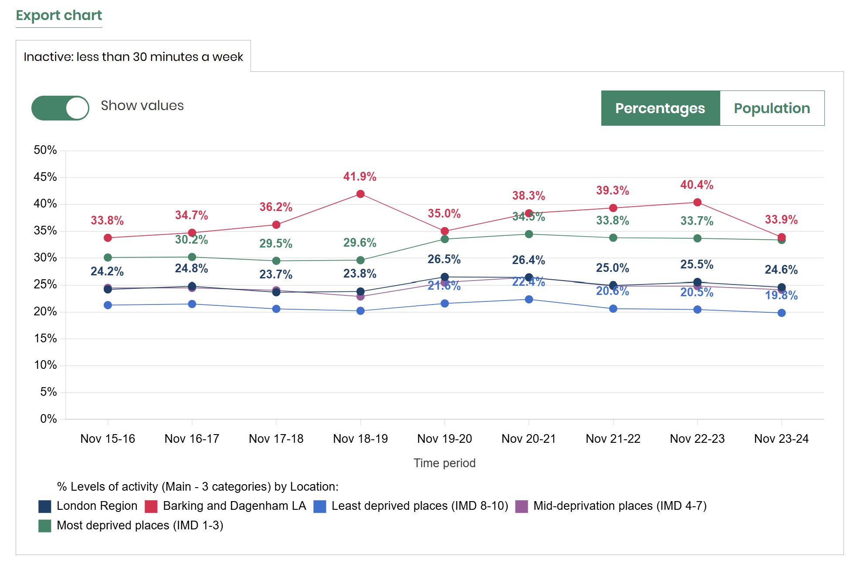

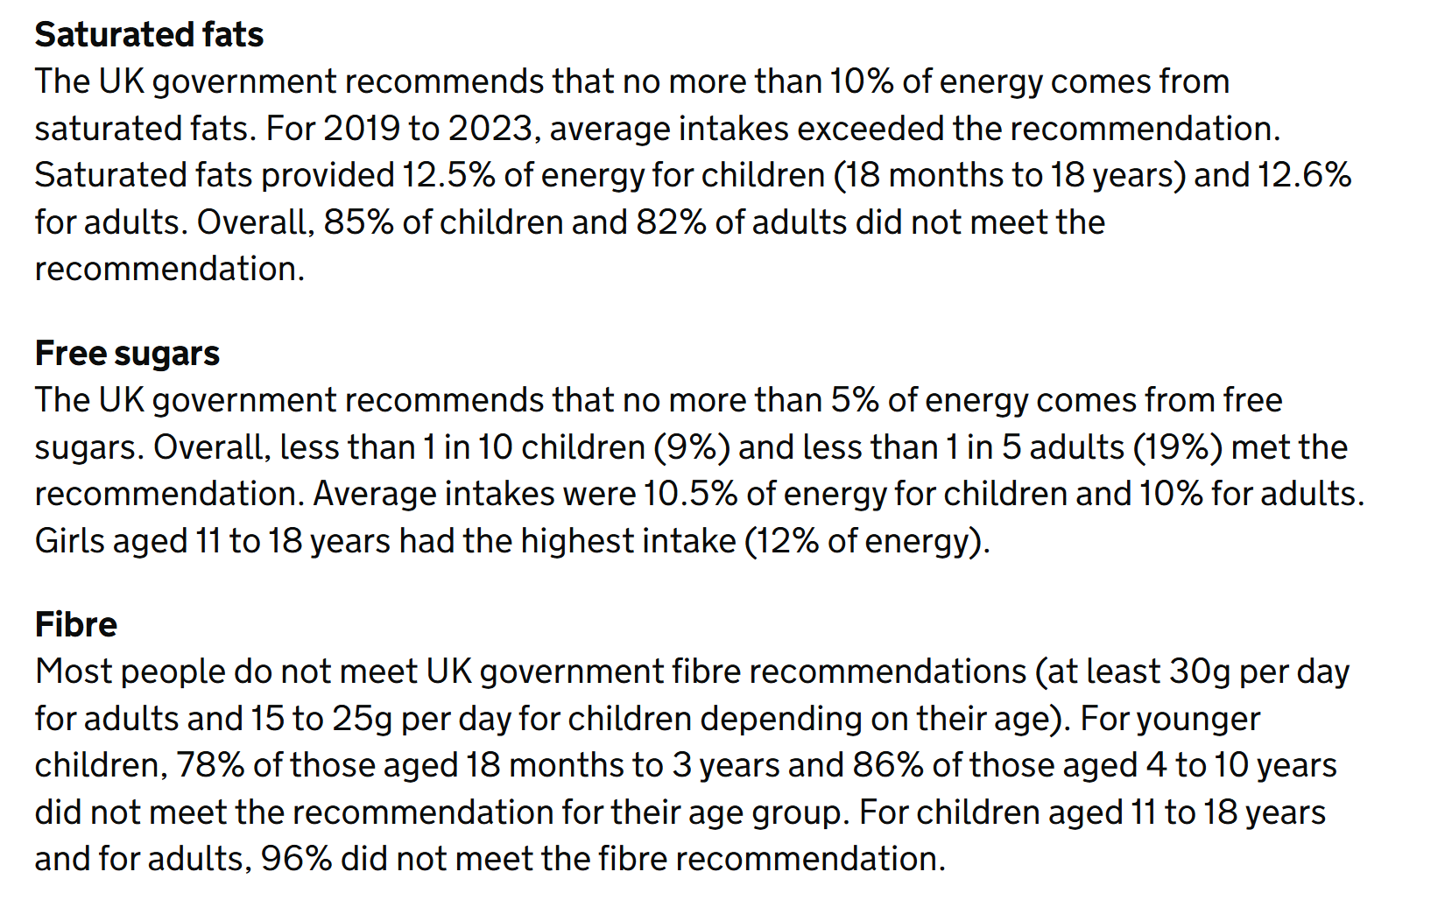
Data analysis and presentation exercises
- Community Lens
Using the Exercise data spreadsheet (download from here), and the Postcode data sheet, paste into the Community Lens tool https://datakind-uk.github.io/community-lens-2025 to create a map overlaying Indices of Deprivation data of new attendees to Care Eat Share in 2025.
  - What percentage of locations are in the bottom 30% of areas in England for IMD?
  - How many locations are in the 2nd and 3rd most deprived deciles for Health deprivation & disability
Download the data sheet
  - How many boroughs do the post code locations fall under?
  - How many participants come from Barking & Dagenham
  - How many come from the Ward that the community centre is based in (use the MySociety Map it tool https://mapit.mysociety.org/ to find out the Ward code for the post code RM6 5NJ - right click on the Ward name to find out further information including its Code [E05014058] )

- Datawrapper

Go to the Datawrapper home page https://www.datawrapper.de/ and select Start creating. Now paste in the data from the General health Census 2021 tab and use Proceed to work through the stages to create a Stacked percentages bar chart ordered by Very bad health for B&D’s Wards. (Take some time to play with the various settings)

- Where does Chadwell Heath rank compared to other Wards?
- What percentage of people have bad or very bad health in Chadwell Heath?

