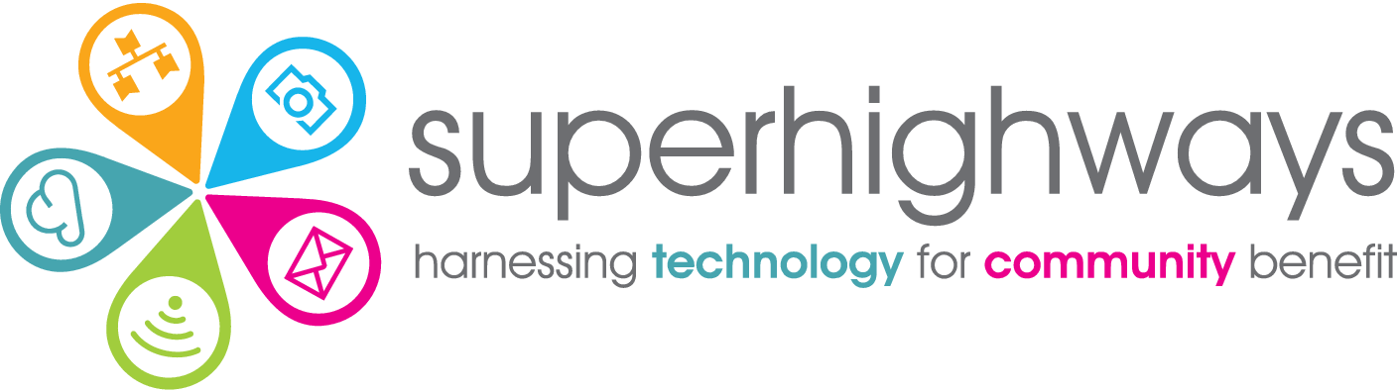

Website Planning Template

- What's the big picture vision for your organisation? Why do you exist, what do you do - and why does it matter? What's the difference you want to create for the people or places you support?

- What are the three most important goals for your website – what do you need it to do for you? Both now and in future?

- Who are your main beneficiaries and stakeholders?

- Who out of this list do you most want to reach with your website? What sort of things do they care about - what keeps them up at night?

Try and put yourself in their shoes. What are the problems they're facing in their lives. What actions will they take on your site to try and resolve some of these? What sort of questions are they looking to answer? In the small charity and community sector it's common to have multiple stakeholders you're trying to reach - but you'll probably have 1-3 that are super important for you.

- What do YOU want people to do on your site?

Think back to what you most need your website to do for you. e.g. register for events, fill in a form to become a member, phone you for help, buy a product etc. Be as specific as you can with the actions they will perform.

- What features do you want your website to have?
e.g. blog, news, social media integration, calendar, embedding videos, forum etc.

- What sections or pages might you wish to include on your site? e.g. About us, contact us.

If you're not sure, that's OK. We will be looking at all of the information you have given us in this form to create a simple page structure that makes sense to you and the people you're trying to reach.

- Please list 3 to 5 ideas for news items / blog posts we can add to the site at launch (if relevant)

- What websites do you like and why? Give 3 examples and include links

