

Charts in Excel

Exercise 1 – Column chart

1. Go to the Attendees sheet
2. Select the area of the sheet containing data
3. 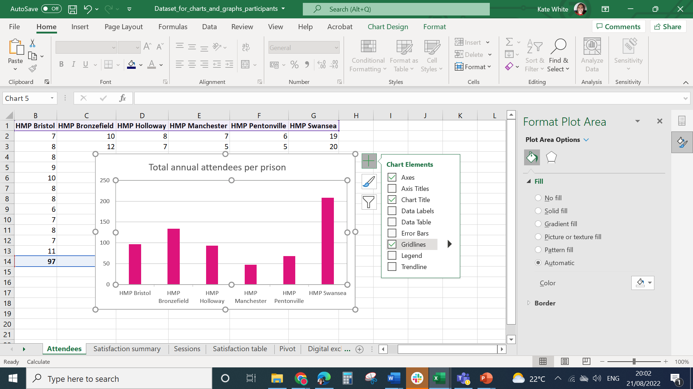Go to Insert and select Recommended Charts and choose the first suggested chart type – a Clustered column chart
4. Add a Chart title *(double click on ‘Total’ and overwrite)*
5. Deselect the Primary vertical axis *(click on the plus sign, hover on Axes, click on the arrow and deselect)*
6. Add Data labels *(check the box)*
7. Deselect Gridlines
8. Change the colour of the columns to dark blue *(double click on one of the columns to select them all and the Format data series side bar should appear at the right. Now select the Paint pot icon at the top and click on the drop down arrow to change the default colour)*
9. Now make data labels appear within the columns *(click on the plus sign, hover over Data Labels and click the arrow. Select ‘Inside End’)*
10. Change font colour to white for contrast *(double click on the figure in the column to select all and the Format data labels side bar should appear. Select Text options at the top and click on the Paint pot to choose white)*

Exercise 2 – Pie chart

1. Go to the Enjoyment sheet
2. Highlight the summary data table
3. Insert chart and this time choose the Pie chart from the Recommended Chart suggestions
4. Now add data labels and change these to percentages *(click on the plus sign, select Data labels and hover and click on the arrow*. *Now choose More options and the Format Data Labels side bar should appear. Now select Percentage and deselect Value).*

Extra advanced exercise - Pivot charts

1. Go to the Enjoyment pivot sheet
2. Click in the Pivot table and then select the Pivot table analyse tab
3. Click on Pivot chart and select the suggested option
4. What’s good & bad about this visualisation?
5. Delete the chart
6. Now drag Satisfaction rating from the Row to the Column area (*in the right hand side Pivot table fields*)
7. Now create a Pivot chart. Is this a better visualisation? Why?
8. Filter to exclude HMP Swansea
9. Add a Chart title

Charts in Datawrapper

See charity examples:

* [NCVO Almanac](https://blogs.ncvo.org.uk/2020/07/08/what-can-the-uk-civil-society-almanac-tell-us-about-charities-challenges-now-and-in-the-future/)
* [Work Rights Centre](https://www.workrightscentre.org/our-impact)

Exercise 1 – Column chart

1. Copy the data from the Sessions tab
2. Go to [www.datawrapper.de](http://www.datawrapper.de) and click on Products in the main menu and select Charts
3. Click Build your own chart and paste in your data. Click Proceed
4. Check your data and then Click Proceed
5. Now you are in the Visualise section, Choose Chart type in the tabs at the top left
6. Choose a Column chart
7. Click Proceed to the Refine tab
8. Add a Title
9. Hide the Gridlines
10. Customise colours and choose a different colour for each Year
11. Switch to showing labels Always (rather than just on hover)
12. Proceed to the Annotate tab and add ‘In 2020 the scheme only ran for 4 months over the year period’ in the Notes section
13. Add Music Mentors in the Data source field

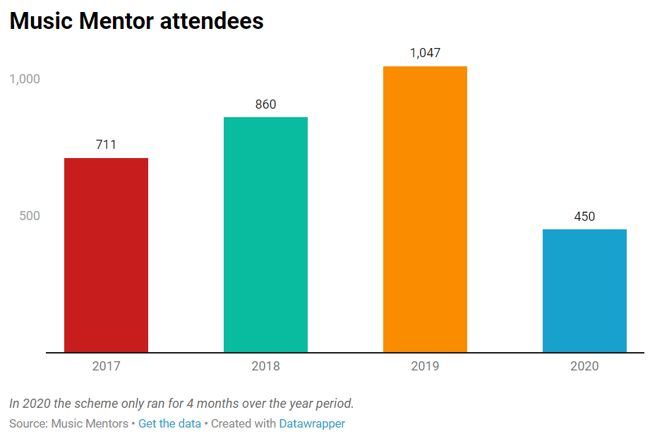

Exercise 2 – Stacked bar chart

1. Go to the Survey results tab and using this data recreate the chart below.

Note: percentage values, right aligned labels, highlighted rows (all in the Annotate tab)

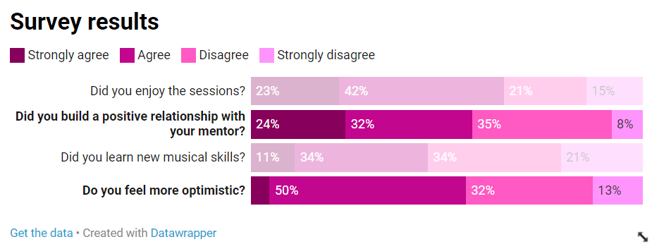

Extra advanced exercise – Bar chart (Grouped)

1. Use the data in the Enjoyment by prison tab to create the below chart

*First choose Bar chart and then in the Sorting & Grouping section, select Group bars by column (*Note: Customise colours to highlight HMP Bristol)

