Planning my website quick template
Perhaps the first question to ask yourself is do you need to start from scratch or can you refresh your current website.
Then…

What 2 or 3 websites do you like and why?
Remember to consider what makes them easy to navigate.

Goal/s for the website

Who do you want to come to your website?
List the groups of people or other stakeholders who might come to your website.

- Priority audience 1:
- Priority audience 2:

Add more as necessary.

What problem do they need to solve? User needs statements
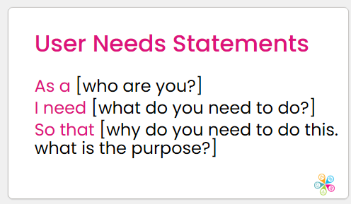

Write as many statements as you can. This can be useful to do with others if you have staff or volunteers who can help.

As a [who are you?]
I need [what do you need to do?]
So that [why do you need to do this. what is the purpose?]

As a…
I need…
So that…

As a…
I need…
So that…

Actions people will take on your website
This is useful to list whether you write user needs statements or not. e.g. book on an event or training
1.
2.
3.

What pages will you need?

Website structure
Simply list the top-level menu items. Use clear, concise language. Add subpages if you can think of them e.g.
- Home
- About
  - Mission and values
- Events
- Impact
- Contact

What is the short sentence on your home page that will help people know they’re at the right place?

What steps should people take from my home page?

Editing text example.
Multiple-comma sentences can often be reworked to just include one comma, which helps to keep things nice and concise, although there are all kinds of exceptions, so this one is certainly not set in stone. Shorter sentences are better than longer ones. If in doubt, use a full stop and move on. That is all. Aesthetics are so important online and first impressions really do matter. Try to break up your articles into bite-sized chunks and avoid multi-idea sentences and paragraphs. Around two to three sentences or less are probably best for a maximum paragraph length.

What assets do you have?
It’s a good idea to create a folder and add your assets e.g.
- Logo in a JPG or PNG file format
- Photos
- Important shareable documents
- Copy for webpages
This includes people:
- Who can help plan your website?
- Who will be an editor?
- Who will write the text?
- Who can help create content such as images or icons?

What platform will you consider?
Make a note of what’s most important for you e.g. storage space, number of editors, embedding content from third parties – such as a Google Form onto a webpage – cost etc.

What is your timeframe??
Remember at least 50% of your time will be the planning, writing and organising before you start building your site.

