PowerPoint: Next Steps exercise list
I will demo each section. Please watch in the Zoom screen before starting each exercise.
Themes and design refresher (from beginners session)
- Create a new blank presentation and add some different content layout slides
- Click on your Title slide*
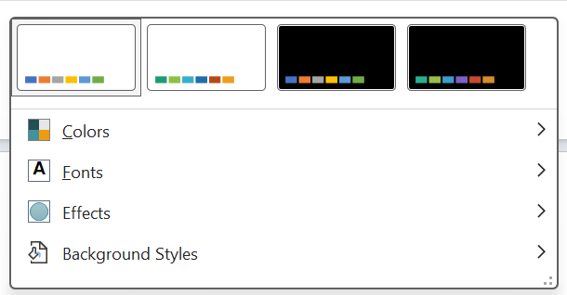
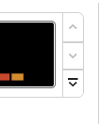
- Go to the Design tab and choose a font variant (use the little drop-down arrow by Variant)

- Customise your colours if you have time (or choose a colour scheme)
- Insert a shape and see the colours available to you. Your slides should now all have your font choices.

Designer
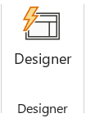
- If you have access to Designer, go back to your Title slide* to take a look at options.
Be aware that if you choose a Designer slide style some Slide Master options will not be available to you.
*It’s important to go back to the Title slide before making changes as this will then apply your new style choices to the whole presentation, not one particular slide.
If you were to duplicate this whole presentation again, it would retain the styling. However, for staff and volunteers you may wish to create a copy of your presentation, delete the details and add placeholder text. Then save as a template.
Branding with Slide Master
Create consistently branded slides by creating a Slide Master style. This style will be applied when you add new slides to your presentation.
Step 1: Colours and fonts
- You cannot use all elements of Slide Master alongside a theme from Designer. Either undo your Designer actions or create a new presentation that includes some content slides.
- Go to View tab
- Click on Slide Master. It has its own toolbar. Any changes you make here are creating a styling to apply to your presentation slides. You must close Master View to return to making changes directly in your presentation.

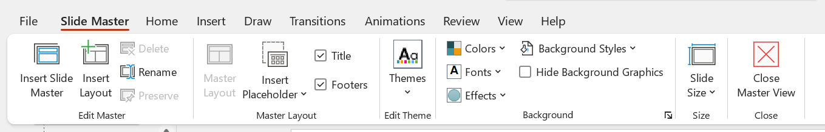
- Choose a theme (if you like)
- Customise your colour scheme and save if you like (you will see it has changed already from our earlier exercise if you are working in the same presentation)
- Change the colour of your title on the top level master slide
- Change your font sizes on your slides
- Tick or untick your footer
- Add your logo
- Add any other shapes or icons that you would like on specific layouts.
- Close Master View
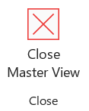
- Have a look at your presentation to see the changes
- Insert a new slide type and add some content

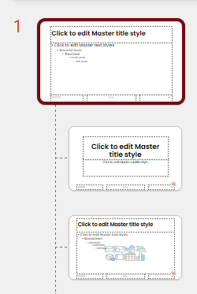
Note: Do you want a style to apply to ALL slide styles
If you want a style to apply to ALL content slide formats you will need to edit the very top slide available to you.
Be careful to only change what is genuinely applicable to all slides. Usually you will be adding objects and animations to each individual slide type.
Be careful what you add to ‘Blank’ slides. A blank slide is useful for large objects (e.g. a full sized video), so you don’t want much design work getting in the way.

Step 2: Layouts and further customisation
- Open Slide Master
- Go to the Home tab and customise your bullet style on the Title and Content slide
- Duplicate this slide and re-name
- Close Master View when you are finished
Note: If you were to duplicate this whole presentation again, it would retain the styling. However, for staff and volunteers that don’t know about inserting different slide layouts, you may wish to create a copy of your presentation, delete the details and add placeholder text. Then save as a template.

Step 3: Adding animations
- Open up Slide Master
- Choose an animation style for your bulleted lists
- Close Master View
- Go to Slideshow and imagine delivering your points
- If you have time, insert your new Title and Content slide format and add some bullet points.
- Don’t forget to go to Slide Show and see your results.
You can simply animate each bullet point (or any individual item) rather than choosing at Slide Master level, depending on the style of your presentation.

Adding animations to objects
- Add an icon and text to a slide
- Choose an animation
- Consider the order of your animations
- You may need to Group items together (either by going to Home and Arrange or by left clicking your mouse to select the objects you want to animate at the same time.

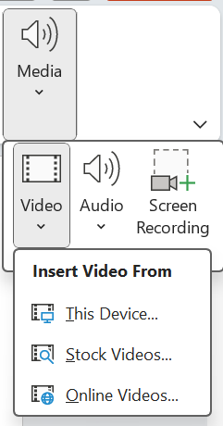
Inserting an online video
- Insert a blank slide
- Go to Insert tab, then Media
- Choose Video
- Add this Online Video: https://youtu.be/8S0FDjFBj8o
- Re-size your video as needed using only the corner handles (you don’t want it to be squished!)
- Have a look at your Video format options (e.g. giving a border colour.
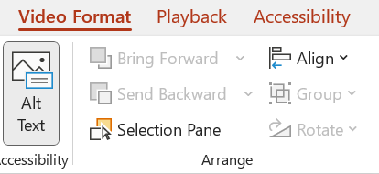
- Check that the Alt Text is correct. If you are adding your own video don’t forget to add your Alt Text if needed.

- Now have a look at your Playback options.
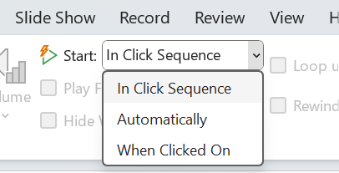
- Choose an option.
- Then go to Slideshow to see how you would present your video

Inserting a video from your PC or laptop
- Insert a new blank slide
- Download this video from Pixabay (it is licenced for free use) https://pixabay.com/videos/forest-autumn-landscape-nature-19580/
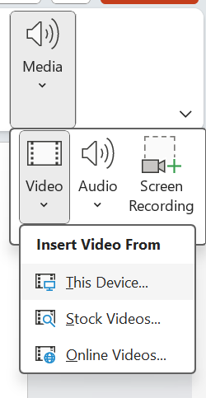
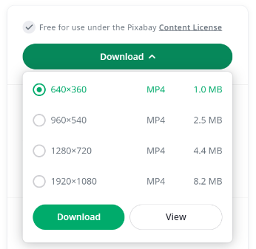
- Download the smallest size
- Insert Video from This Device
- Check your playback options again
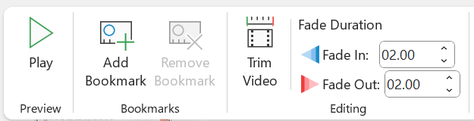
- Now add a 2 second fade in and out

- Trim your video to 11 seconds if you have time
- Playback and see what happens.

Insert audio
- Download this sound effect from Pixabay https://pixabay.com/sound-effects/forest-light-rain-27482/
- Insert Audio
- Go to Playback and choose the options Play in Background and Start Automatically.

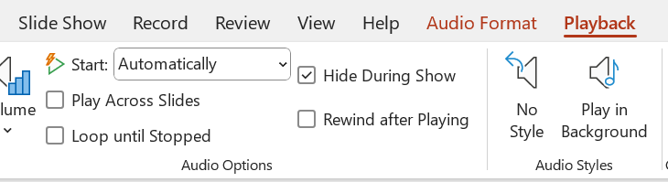
- Click on your video, go to Playback and change your start to be Automatically. Your video and sound will now be in sync.

You can also record narrations in slides. You may need to tick the box to Play Across Slides if you narration or audio needs to cover more than one image or video.

Insert a table
- Insert a new slide
- Insert a table
- Paste in the data from Music Mentors tab of this Google Sheet (you will find it easiest to keep the same formatting and then edit to make changes)
- Re-size your table using the handles
- Adjust your columns to fit
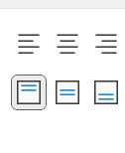
- Align your text to top (by default it’s usually aligned to the bottom)
Header row is ticked by default. You may wish to turn this off if your table does not contain data that needs headings.

Insert a chart
- Insert a new slide
- Insert a Column chart and look at your available options
- Copy and Paste the theme occurrences in the tab called ‘Bar Chart’ from this Google sheet
- Go to Add Chart Element or the plus sign beside your chart and change the Chart Title to none
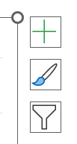
- Change Legend to none
- Give your slide the title of the chart
- Add data labels at the Outside end of the columns
- Change the colour of the first two columns
- Have a look at your other options
Some chart types may require you to change your data order in Excel to tell the right story. For example, if you now change to a Bar Chart you will see the highest frequency is at the bottom of the chart. You will need to Edit the data in Excel to reorder from smallest to largest:

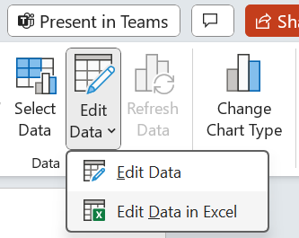

The go to the Data tab and use the big sort function.
