**Analysing your Survey Data session**

**Exercise sheet**

*\*Top tip – make a copy of your survey results Excel file before starting your analysis so you have the raw data to go back to if you need it.*

**Exercise 1 – Pivot Tables & Charts**

**Part 1**

1. Click anywhere in the data in the Survey results sheet and change to a Table (Insert tab, Table) and name it “Surveyresults” (rename in the top left of your screen)
2. Now create a Pivot table (Insert tab, Pivot table) and rename it Surveypivot (top left) and also rename the Sheet (double click on sheet tab at the bottom and rename Survey pivot)
3. Now select the PivotTable fields PrisonID, Enjoyed the sessions, adding PrisonID to the Values quadrant (bottom right), and the Prisons to the row and Enjoyed the sessions to the column quadrant.
4. Now add Prisons in the PivotTable fields list. Change the layout to see different views – first drag Prisons so sits above Enjoyed the sessions field in the row quadrant. Now drag Prisons to the column quadrant
5. What does the data tell you? What might you want to investigate further? Add other fields to the PivotTable to delve into your data some more.

**Part 2**

1. Now simplify by just selecting the 3 fields above – this time with Prisons in the row quadrant and Enjoyed the sessions in the column quadrant
2. Create a PivotChart (click in PivotTable data, go to PivotTable Analyse tab and then select Pivot Chart, going with the suggested chart.
3. Are there any issues when comparing prisons? What problem can you see?
4. You could convert to percentages – go to the Count of Prison ID (bottom right quadrant) and click on the down arrow to open up the Value field settings box. Select the Show Values As tab and choose % of Row Total option from the drop down menu.

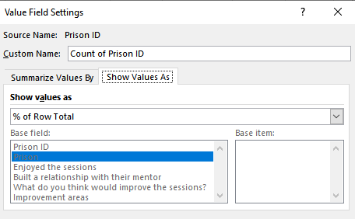

1. Now click on the Chart and the Design tab and select to Change chart type. Choose the Stacked column chart

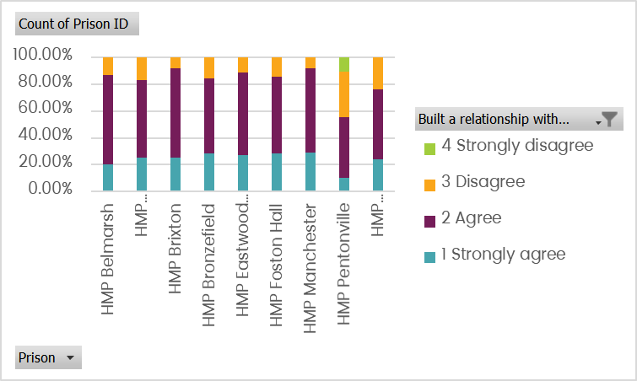

*\*Top tip – if you are pasting charts into reports e.g. in Word, paste as an image, otherwise the chart will change when you are making changes to your PivotChart (otherwise it is linked by default!)*

***Extra exercise – Looking at change***

1. In the Survey results sheet, add a calculation in the Change column (Column I) to show the change in Optimism scores =H2–G2 (the formula should automatically copy down)
2. Create a new PivotTable and call it Changepivot
3. Select Prison ID, Prison and Change in the PivotTable fields and drag Prison to the row and Change to the column quadrant, with Count Prison ID in the Values quadrant
4. In the PivotTable, click on the Column label arrow and reorder AtoZ
5. Now create a bar chart showing the distribution of Change scores across the Prisons
6. Now filter the chart to just show the 4 prisons beginning with B
7. Which prison looks to have achieved the best results in terms of the Change in optimism? Which prison has comparatively not done so well?

**Exercise 2 – Analysing multi select multiple choice answers**

**Part 1 – Total Row**

1. Go to the Multiple Choice 1 sheet and click in the Table and add a Total row – Go to the Table design tab, and in the Table style group (centre of the menu) tick the Total row option
2. Now scroll down and under the Saxophone click on the Down arrow and choose Count.
3. Now copy this formula across to the neighbouring cells
4. How many people have prior experience of playing the guitar? (Answer 55)

**Part 2 – Text Filter**

1. Go to the Multiple choice 2 sheet and use Text filter to filter on a particular instrument (click on the down arrow in the Column header and then type in the instrument name in the Text filter box)
2. Check you get the same answer for guitar

**Part 3 – Count If**

1. Go to the Multiple choice 2 sheet and look for the summary table in columns E & F
2. Add the Countif formula in the cell next to each instrument to return the count of numbers of each one. E.g. in cell F3 add the formula =Countif(select column C, “*Bass*”) and repeat for each instrument.

*\*Top tip – copy down the formula and manually overwrite for each instrument*

|  |  |
| --- | --- |
| **Instrument** | **Number** |
| Bass | 34 |
| Drums | 79 |
| Guitar | 55 |
| Electric Keyboard | 105 |

1. Now select this summary table and create a chart to visualise this data (Select data and go to the Insert tab, Recommended charts (towards the centre of the menu bar)

**Exercise 5 (demo) – Unpivot data method 1 (tabular)**

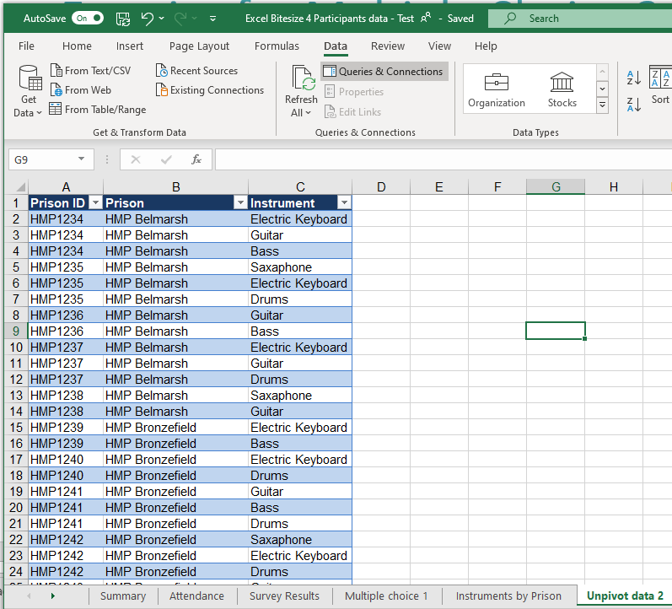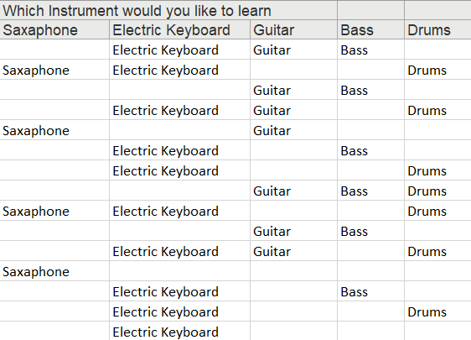

1. In the Multiple Choice 1 sheet, click in the data and make the data into a Table (Insert tab, Table or shortcut Ctrl +T). Name it “Multiplechoice1”
2. Open the Power Query Editor (Data tab, and in the Get & Transform Data Group select the From Table/Range button)
3. Unpivot the data (Highlight the columns to unpivot using the shift key-Transform tab-Unpivot data button)
4. Remove the Attributes column (Right mouse click – Remove)
5. Rename the Values column “Instrument” (Right mouse click-Rename)
6. Upload & Close the query (Home tab – Upload and Close)
7. Rename the results worksheet “Unpivoted data 1”

**Exercise 6 (demo) - Unpivot data – method 2 (delimited)**

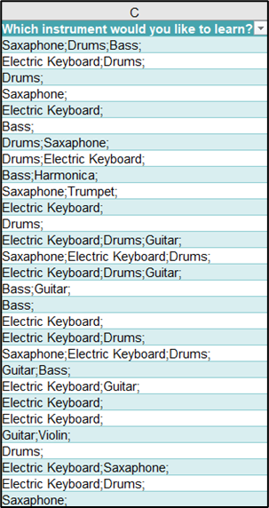

1. Go to the Multiple Choice 2 worksheet
2. Rename the Table “Unpivotdata2”
3. Open the Power Query Editor (Data tab – From Table/Range button)
4. Split the data in the column (Home tab- Select column - Split Column button-select a semi colon as the delineator)
5. Unpivot the data (Highlight the columns to unpivot using the shift key-Transform tab-Unpivot data button)
6. Remove the Attributes column (Right mouse click – Remove)
7. Rename the Values column “Instrument” (Right mouse click-Rename)
8. Filter out the blank rows (Filter on Values column – deselect blanks)
9. Upload & Close the Query (Home tab – Upload and Close)
10. Rename the results worksheet “Unpivoted data 2”

**Exercise 7 – Coding open text responses**

1. Unhide Column F (highlight columns E & G either side, right click and select Unhide) to reveal the pre prepped coding
2. Open the Power Query Editor (Data tab – Get & Transform data tab and Table/Range button)
3. Select the columns to include in the query results as: Prison ID, Prison, What do you think would improve the sessions?, Improvement areas (Home tab – Choose Columns – Select from the list)
4. Split the data in the Improvement Area column (Transform tab -Split Column button-By Number of characters 1 checking that Repeatedly is ticked too)
5. Unpivot the data (Highlight the columns to unpivot - Transform tab - Unpivot data button)
6. Remove the Attributes column (Right mouse click in the column header – Remove)
7. Rename the Values column “Improvement areas” (Right mouse click in the column header – Rename)
8. Upload & Close the Query (Home tab – Upload and Close)
9. Use Find & Replace to replace the number codes with text (copy the text box from the survey sheet to make it quicker) (Or you could stick with the number for now and rename in the Pivot table created below)

**Exercise 8 – Creating a pivot chart**

1. Create a Pivot table in the Unpivoted data 3 worksheet (Click in the Table, Insert menu – Pivot table)
2. Rename the new worksheet “Improvement areas”
3. Add Improvement Area to the Rows & Prison ID to the Values field areas
4. Add What do you think would Improve the sessions? To the Rows under Improvement Areas
5. Use the + and – on the Row to show/hide rows
6. Sort the Pivot chart by number of people per row (Arrow next to row column, More sort options – Descending – Count of Prison ID)
7. Add a pie chart (Click in the Pivot Table, PivotTable Analyse menu-Pivot Chart)
8. Format the pie chart to show percentages (Click on pie chart, Design tab-select a format with percentages)
9. Remove the field Count of Prison ID (Right click on the field in the chart – Remove)
10. Hide all field buttons (Right click on a field in the chart – Select Hide All Field buttons)
11. Rename the chart (Double click into the Title to type in a new heading)

