
Excel Next Steps 1 – Session Exercises

Topic 1 – Tables
In the Attendance sheet
- Make the data on the Attendance sheet into a table (Insert tab, Tables group at left-hand end of Ribbon, Table command)
- Name the table 'Attendance' (Click anywhere in your data set, go to the Table Design tab and type the Table Name in the space provided in the Properties Group at the left-hand end of the Ribbon)
- Format the table to make it a different colour (Table Design tab, Table Styles group)
- Use Auto Sum to work out how many people attended in total each month (Home tab)
- Add a Total row to see the total number of people who attended over the whole period (Table Design tab, Table Style Options group, select Total Row tick-box)
- How many attendees in total attended sessions at HMP Manchester? (In your Total Row – click in cell G40, click the arrow to open the command options box and select Sum)
- How many attendees attended on average per session at HMP Bronzefield? (In your Total Row – click in cell F40, click the arrow to open the command options box and select Average)

Topic 2 – Part 1 - Filtering
In the Participants sheet
- Make the data in the Participants sheet into a table and name it ‘Participants’ (Insert tab, Table. Name the Table in the Properties group in the top left of your screen)
- Sort by Prison (A-Z) & Name (A-Z) (Data tab, Custom Sort command, add your Sort levels) How many people attended the programme from HMP Holloway? (Both those who did and did not have a welfare session)
- Add a filter on the ‘Enjoyed the sessions’ column to show only records where people ‘Really enjoyed’ the session.
- How many participants really enjoyed the sessions?
- Now also filter on those who also ‘Enjoyed’ the sessions.
- How many people ‘Really enjoyed’ or ‘Enjoyed’ the sessions?

Topic 2 – Part 2 – Advanced Filtering
In the Participants sheet
- Clear previous column filter (applied to Enjoyed the session column) Add a text filter on the Instrument experience column so that only rows which contain the word “guitar” are displayed.
- How many people have experience of playing the guitar?
- Clear the filter.
- Add an advanced text filter on the Musical Instrument column so that rows which contain “guitar” or “bass” are shown.
- How many people have experience of playing either the guitar or the bass?
- Clear the filter.
- Add a slicer for Prison (Click in your data and select the Table Design tab and Insert Slicer from the Tools group)
- How many people attended from HMP Holloway?

Topic 3 – Conditional formatting
In the Participants sheet
- First sort on prison A-Z
- Highlight the duplicates in the Name column (Home tab, Styles group, click on arrow next to Conditional formatting command, select Highlight Cell Rules, choose Duplicate Values, select the format you want, click OK)
- Identify which rows really are duplicates and which are different people.
- Remove Duplicate people by manually deleting the identified rows. You could use the Remove Duplicates command if your duplicate rows contain identical data (Data tab – Data Tools group – Remove Duplicates command 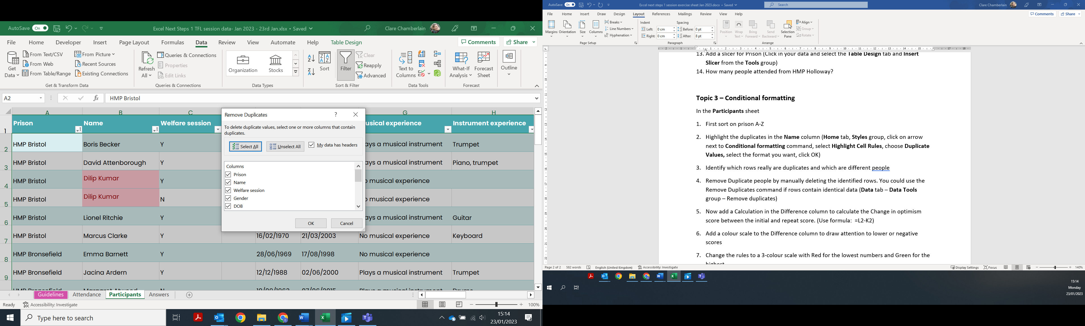 If your data is in a table you will need to Unselect All column headers and choose Name) Excel will always delete the second record it finds.
- Now add a Calculation in the Difference column to calculate the Change in optimism score between the initial and repeat score. (Use formula: =L2-K2)
- Add a colour scale to the Difference column to draw attention to lower or negative scores.
- Change the rules to a 3-colour scale with Red for the lowest numbers and Green for the highest.

