Hands on Datawrapper training session

Examples:

* [NCVO Almanac](https://www.ncvo.org.uk/news-and-insights/news-index/uk-civil-society-almanac-2022/" \l "/)
* [Work Rights Centre](https://www.workrightscentre.org/our-impact)

Exercises:

Exercise 1 – Column chart

1. Copy the data from the Sessions tab
2. Click Build your own chart and paste in your data. Click Proceed
3. Check your data and then Click Proceed
4. Now you are in the Visualise section, Choose Chart type in the tabs at the top left
5. Choose a Column chart
6. Click Proceed to the Refine tab
7. Add a Title
8. Hide the Gridlines
9. Customise colours and choose a different colour for each Year
10. Switch to showing labels Always (rather than just on hover)
11. Proceed to the Annotate tab and add “In 2020 the scheme only ran for 4 months over the year period” in the Notes section
12. Add Music Mentors in the Data source field

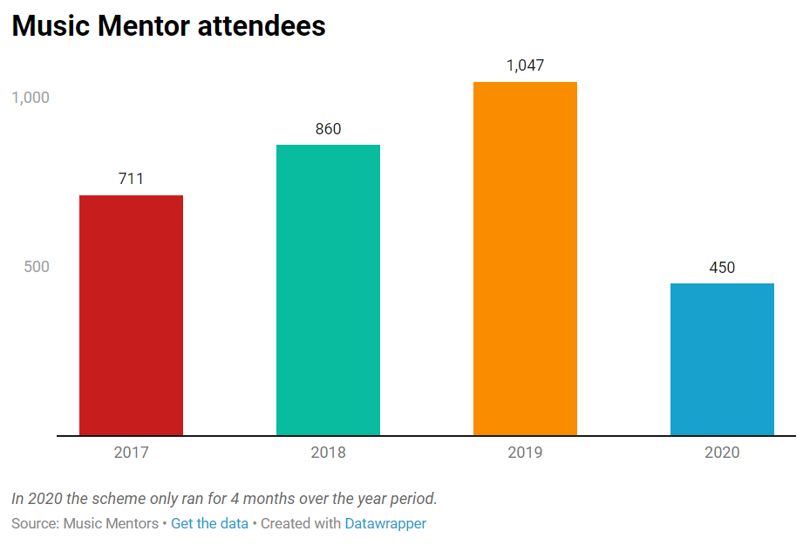

Exercise 2 – Pie chart

1. Close the spreadsheet, click to Create a new chart and choose the XLS/CSV Upload option
2. Now choose the Enjoyment rates Sheet from the drop down menu
3. Choose the Pie chart option - if not visualising correctly, go back to the Check and describe section and choose to Transpose the data (look under the data table)
4. Change the Slice colour to #222299
5. Change to Sort by Smallest first
6. Change the Number format to Percentage
7. Use the Colourblind check to see if the contrast is clear enough
8. Click Proceed or Select the Annotate tab
9. Add a Title & Description
10. Click Proceed or Select the Layout tab
11. Uncheck the Data download option and Enable the Image download option
12. Click Proceed and then the PNG export option
13. Download your pie chart as a PNG file

Exercise 3 – Stacked bar chart

1. Open the spreadsheet again and go to the Survey results tab and using this data recreate the chart below.

Note: percentage values, right aligned labels, highlighted rows (Annotate tab)

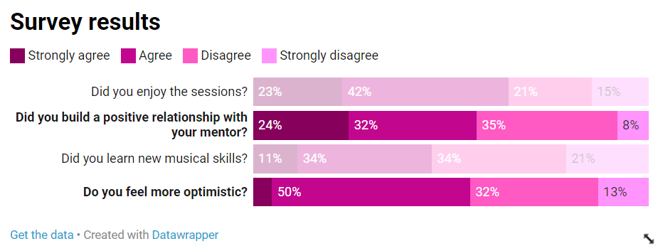

Exercise 4 – Bar chart (Grouped)

1. Use the data in the Enjoyment by prison tab to create the below chart

*Choose Bar chart and then in the Sorting & Grouping section, select Group bars by column (*Note: Customise colours to highlight HMP Bristol)

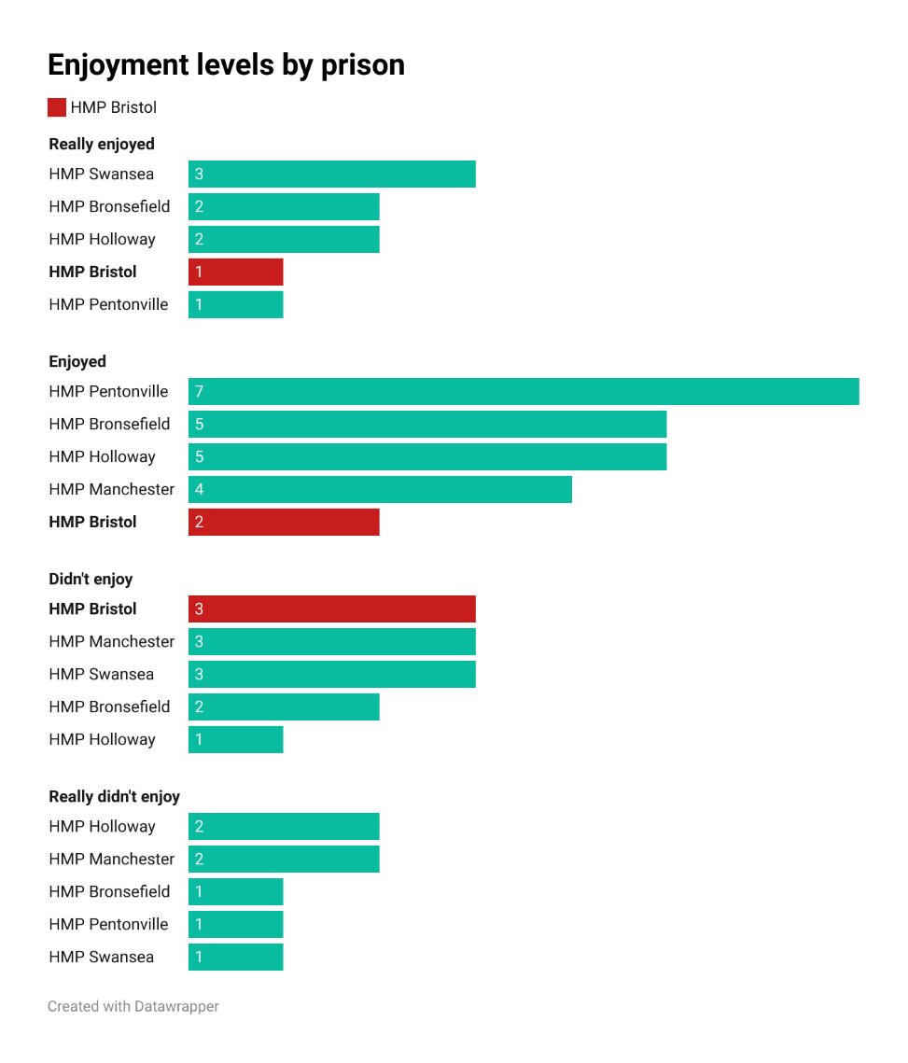

**Exercise 5 – Line chart**

1. Go to the Attendees tab and using this data, create the chart below.

(Note: vertical grid lines, custom colour for HMP Bronzefield, line labels at the top, line symbols – circle)

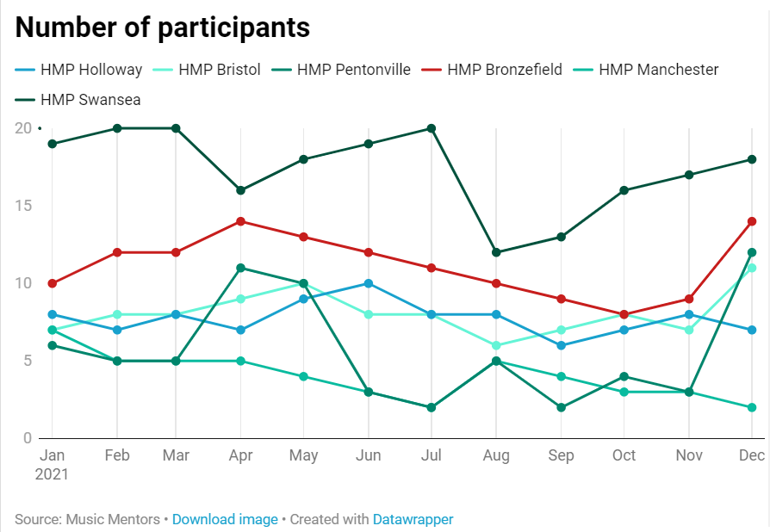

**Exercise 6 – Choropleth Map**

1. Choose create Choropleth map option
2. Search London – Sutton wards
3. Upload data from the Sutton Advice Users tab
4. Choose you preferred colour palette, legend format

**Exercise 7 – Boroughs Choropleth Map**

1. Choose Choropleth map – search Greater London and select
2. Upload data from Borough stats tab
3. In Annotate add title,
4. In Annotate choose show Map labels– add boroughs by clicking on Show labels, select by column and select LA name to show boroughs on map

