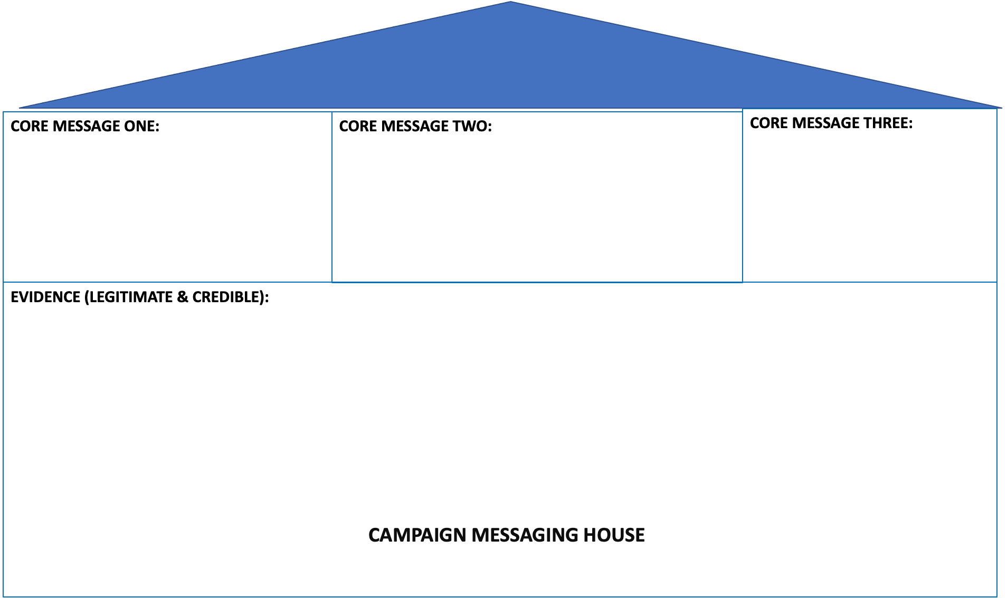

3x simple stats – including

Personal stories – ‘safe’ details

Other anecdotes from your network

Call to action

Answer common criticism to your solution

Explain your solution