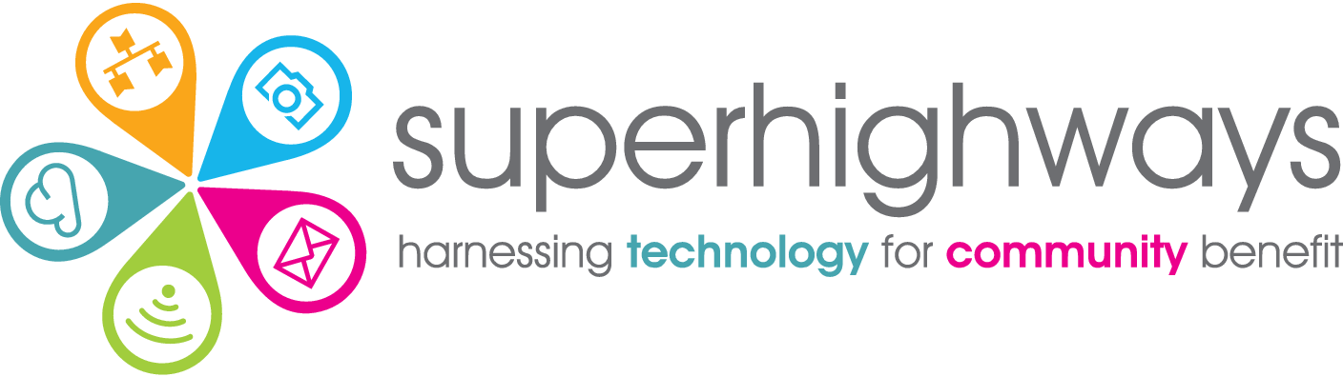  

# Recruitment Pack

Data Analyst

## About us

Superhighways, a project of Kingston Voluntary Action, believes in strong, adaptable communities confidently using data and digital to meet their needs and aspirations. We're on a mission to help small charities and community groups in London gain essential digital and data skills, backed by the right tech, to achieve their goals.

Our approach to our work is:

* **Relationship centred:** we build meaningful relationships based on respect, honesty and care
* **Capability-minded:** we are approachable and patient, encouraging learning by doing, where no question is a silly question
* **Committed to value:** we meet people and teams where they are, finding the most appropriate and forward-thinking solutions
* **Enthusiastically curious**: we are always discovering new techniques and tools, offering engaging ways of learning and bringing fun and playfulness to all we do
* **Community spirited:** we foster collaboration and togetherness, connecting people with shared experiences for the good of the whole community, leading when appropriate

Our small but mighty team run a range of projects and services, alone and working collaboratively in partnership with others. See [www.superhighways.org.uk](http://www.superhighways.org.uk/) for further information.

Our data support programmes

Our [Datawise London programme](http://www.datawise.london), funded by City Bridge Foundation as part of the Cornerstone Fund, focuses on a systems change approach to improving data use by civil society in London, with five overlapping strands of work:

* Data journeys​
* Data platforms and tools​
* Data learning resources​
* Data about the sector​
* Peer to peer data spaces

We are also funded by Trust for London to deliver a [data capacity building programme](https://superhighways.org.uk/training-advice-and-technical/data-essentials/) for London’s grassroots organisations working for a fairer and more equal London, so that they can better use data to shape services and raise the voice of their communities to influence change.

About you

We are looking for an exceptional individual to join our small friendly team to expand our inhouse data capacity and expertise. You’ll be working alongside Superhighways colleagues to help build systems and analyse data as part of our Datawise London programme and associated consultancy projects.

You'll be as comfortable crunching numbers, analysing datasets and acting on insights as you are supporting and mentoring others. Your excellent communication skills will help non-technical staff develop the confidence and critical thinking skills they need to define requirements for systems and analyse interneal and external data. A passion for Excel, databases and data visualisation tools is a must!

You will be enthusiastic, enjoy working on a variety of tasks, and motivated to further your data skills.

Recruitment timetable

To apply for the post – please download and complete this application form [from our website](https://superhighways.org.uk/we-are-hiring/) and return by mail to Superhighways, c/o Kingston Voluntary Action, Siddeley House, 50 Canbury Park Road, Kingston, KT2 6LX or email [jobs@superhighways.org.uk](mailto:jobs@superhighways.org.uk)

Closing date for applications: Monday 23rd December at 10 am

Shortlisting decisions communicated: Tuesday 24th December by midday

Interviews: Tuesday 7th January

*Read on for the Data Analyst Job Description and Person Specification.*

Data Analyst Job Description

Purpose: To enable small charities and community groups gain new data skills and use the best digital tools and platforms available, to shape services and influence change.

Responsible to: Data Programmes Lead

Salary & benefits: £29,500 - £32,500 pro rata. Full time 35 hours. 27 days annual leave pro rata + bank holidays. 5% pension contribution.

Contract: 6 month initial contract (with the potential to extend subject to continuation funding being secured).

Location: Flexible hybrid working, remotely from home and from our central Kingston office.

Summary: To develop and support the use of a range of data tools and systems to help small charities and related stakeholders, collect, store, analyse and present the data they need to shape services and influence change, delivered under our Datawise London programme and consultancy projects.

Key tasks

1. Collect, clean, and analyse data from various sources (open data and from inhouse systems)
2. Develop and maintain data models, dashboards, and reports
3. Research and test a variety of data tools for data collection, analysis & presentation
4. Provide support and advice to small charities implementing a variety of CRMs / databases and reporting tools
5. Develop and support inhouse built low-code/no-code database tools (for our own use and by other organisations on a consultancy basis)
6. Mentor small charities to build their own database using low-code/no-code tools
7. Support delivery of a range of user groups e.g. PowerBI and AirTable
8. Collaborate with cross sector partners (voluntary, statutory and private) to create peer networks and solutions to shared challenges
9. Support the Superhighways team with data outputs and insight gathering
10. Signpost to other relevant data support services, resources and external data sources
11. Support other related work under our Datawise London programme and consultancy services as needed

Other duties

1. Contribute content to the Superhighways eNews, social media posts and blogs
2. Monitor and evaluate programme delivery to ensure high standards, inform future improvements, and meet targets set using our CRM (AIDE)
3. Work as part of the Superhighways team, contributing to our vision and mission, and embodying our approach to our work
4. Work within agreed work plans, manage own workload and be self-servicing
5. Attend Superhighways team and Kingston Voluntary Action staff meetings and training as required
6. Operate in accordance with Kingston Voluntary Action’s values, policies and procedures

### Person specification

Essential

* Degree level or equivalent work experience in a data analyst or similar role
* Excellent knowledge of data best practice including GDPR compliance
* Excellent analytical skills and problem-solving skills
* Intermediate / advanced spreadsheet skills using Excel and/or Google sheets
* Good Knowledge of business intelligence tools like Power BI or Tableau
* Familiarity of working with databases & data models
* Experience working on a range of data projects, analysing datasets and acting on insights
* Experience using a range of data analysis and visualisation tools, techniques and systems
* Experience sourcing and using data from a range of open data sources
* Creating support resources in a range of formats to help others utilise data effectively from introductory to more advanced levels
* Excellent organisational and workload management skills, able to work both independently and collaboratively
* A passion for using data to make a real difference for small charities and community groups
* Enthusiasm to share knowledge and skills, and motivate others to learn
* A committed team player with a collaborative, flexible and generous approach to working with colleagues and sector organisations
* Commitment to working positively and valuing and celebrating diversity and inclusion
* A proactive and self- motivated learner developing skills and testing new approaches and solutions

Desirable

* Knowledge of Python, R and/or SQL
* Use of No-code/Low-code solutions e.g. Airtable, Knack or Zoho
* Knowledge and/or experience of capturing user requirements and defining systems requirements
* Knowledge and/or experience of digital transformation - implementing new software, tools and working practices within an organisation
* Group facilitation skills
* Training skills